

Cartegraph Users Guide
Basic Training

Contents
Introduction 2
Quick Start Up Guide 2
Logging In 3
Web Application 3
Mobile Application 4
General Navigation 7
Web Application – initial login view 7
Dashboard 9
Requests – web application 10
General Information 10
Work – web application 11
General Information 11
Assets – web application 12
General Information 12
Filtering 13
Detail Views 16
General Information of Detail Views 17

Introduction
Cartegraph is an Asset Management and Work Order Management software which helps government entities track where assets are located, how much it costs to maintain those assets, extend the life of those assets, and help determine future costs of maintaining those assets.

Cartegraph was first made available in 1994 and was bought by OpenGov in 2022. Douglas County started using Cartegraph with their first implementation of the Public Works – Traffic division in June of 2019. This was followed by the Parks, Trails, and Building Grounds division implementation in May of 2020. Public Works Engineering (Pavement management) transitioned to Cartegraph Scenario Builder feature in March of 2021. The Stormwater Asset management program started using Cartegraph in January of 2024 and the Public Works Operations division transitioned to Cartegraph in June of 2024.

Quick Start Up Guide
Cartegraph offers multiple methods of accessing their application and logging into their application. Douglas County utilizes both their web application and mobile application. The web application can be accessed via any browser. The mobile application is made available via the Apple store and Google Play. Mobile devices managed by Douglas County will automatically push the current mobile application to those devices which require that application to be accessed.
Logging into the application does require the staff member to also have an ArcGIS Identity as this is the method that Douglas County leverages to log in to the application. If you are provisioned with access to Cartegraph, you will also be provisioned with an ArcGIS account.

Logging In

Web Application
- Launch your preferred browser (Google Chrome, Microsoft Edge etc….)
- Navigate to https://cgweb11.eamclassic.opengov.com/DouglasCoCO/Account/ShowSignIn
- Click on Sign in with ArcGIS
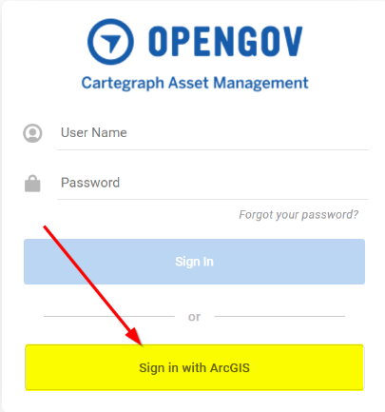
- If this is the first time you have logged in, you may get asked to enter “Your ArcGIS organization’s URL”
- Enter dougco in the box and select the Remember this URL (remembering the URL will allow you to skip this step the next time you log in.
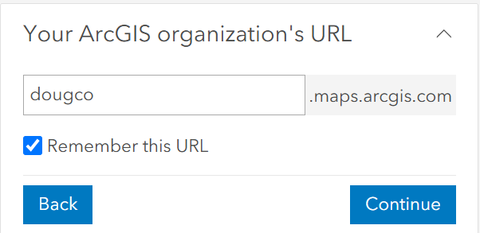

- Once that URL is remembered, select Dougco on the next screen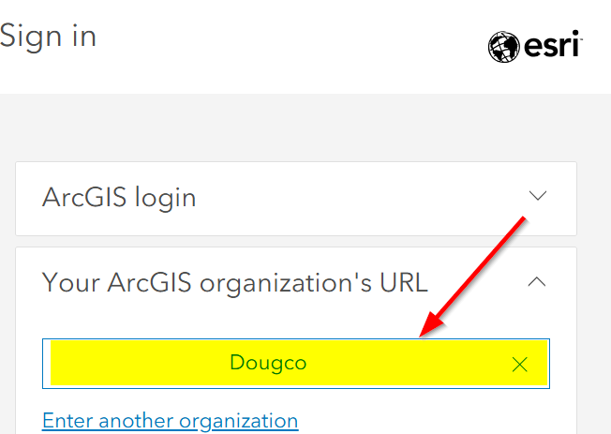
- Select Douglas County on the next screen
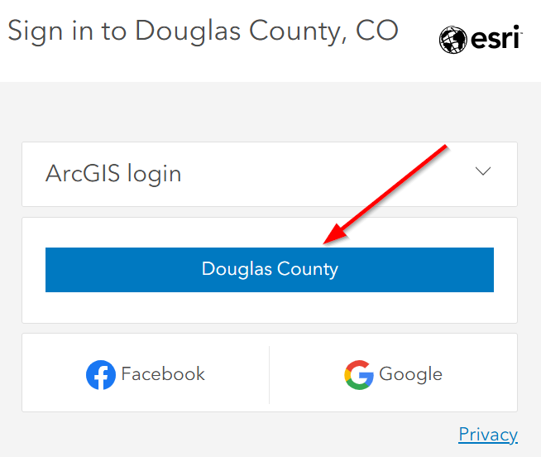

Mobile Application
- Locate the Cartegraph Asset Management Icon from iPad/iPhone screen
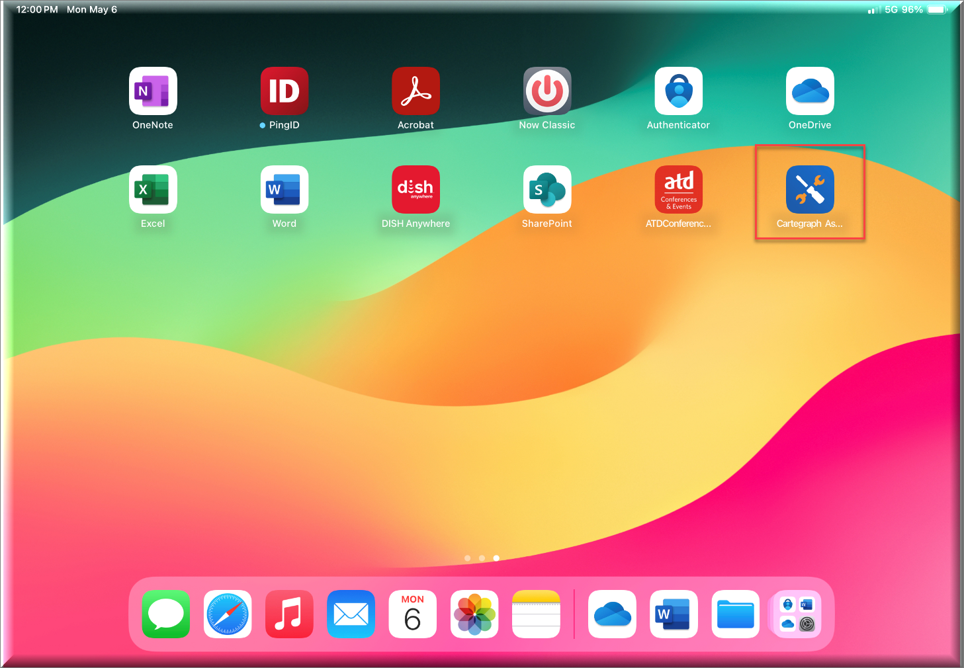
- If this is the first time you have launched the application, select “Allow While Using App” if you are asked to use your Location. Turning that on will assist in using the application while in the field
- Either type in the following Server URL or select the QR Code icon to the right
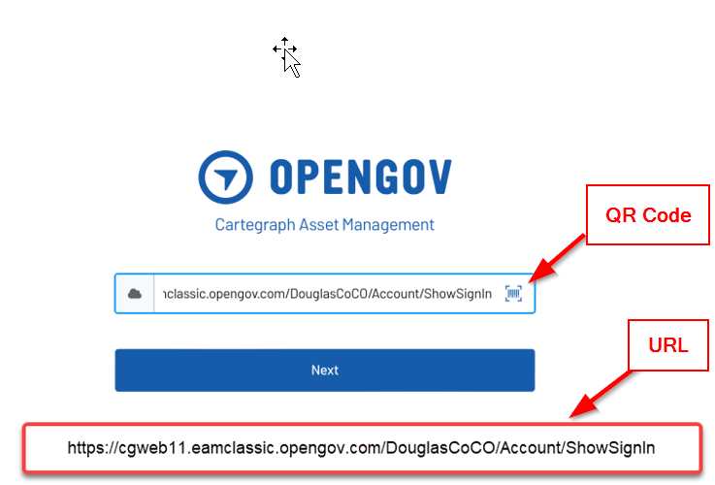

  - QR Code:


- Select Sign in with ArcGIS
- If this is the first time you have logged in, you may get asked to enter “Your ArcGIS organization’s URL”
- Enter dougco in the box and select the Remember this URL (remembering the URL will allow you to skip this step the next time you log in.

- Once that URL is remembered, select Dougco on the next screen
- Select Douglas County on the next screen

- If you are presented with the following, enter your email address and your Douglas County network password and then select Sign In
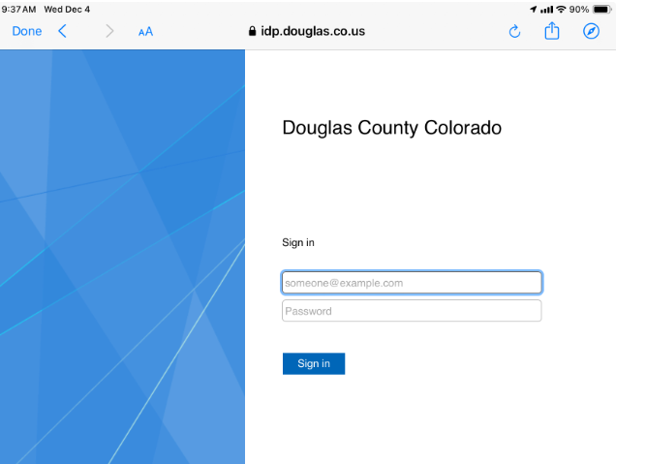

General Navigation

Web Application – initial login view
After logging into the application, you will be presented with the Dashboard view. Based upon the permissions you have in Cartegraph, you may have access to some or all the following.

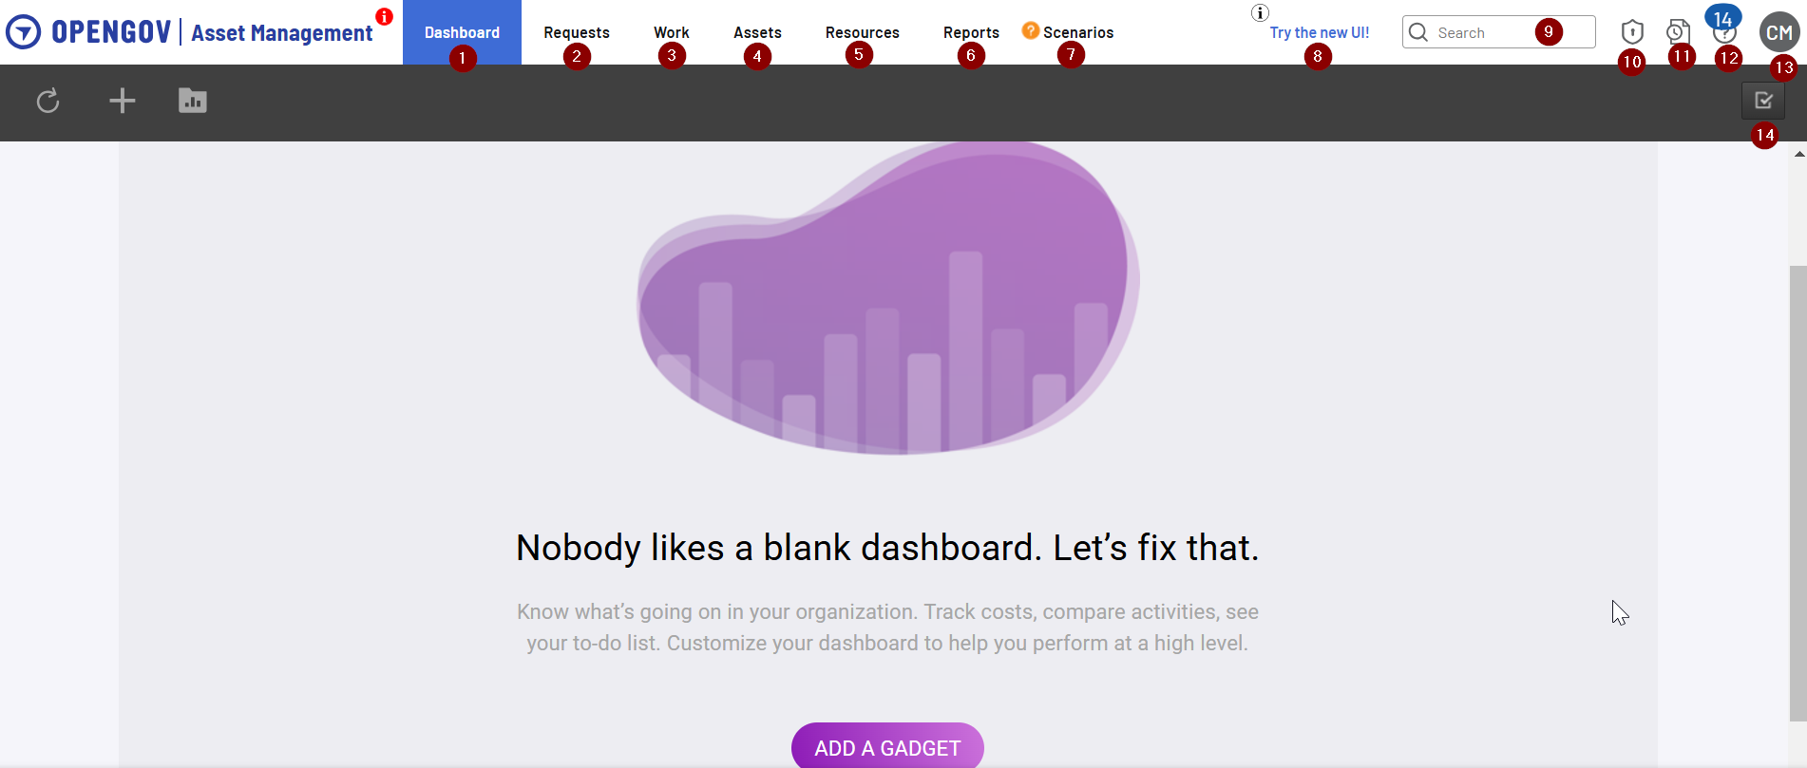
- Dashboard - Provides access to canned Graphs and Reports, custom Graphs and Reports and ability to create your own Graphs and Reports. When you first login you will see a screen similar to the above showing a “blank dashboard”
- Requests – Also known as Service Requests or Citizen Complaints
- Work – allows access to Work Orders and Tasks
- Assets – allows access to all maintained (based upon permissions) Assets such as Storm Conduits, Pavement, Signs, Signals etc….
- Resources – allows access to Labor, Labor Crews, Equipment, Material, Material Location, Material Order and Vendor
- Reports – allows access to many canned reports and custom reports built by and for the County
- Scenarios – allows access to the Scenario Builder feature of Cartegraph
- Try the New UI – this is also known as the Mobile application view and this is also the future look and feel of the Cartegraph application. As of December 2024, OpenGov is still building out the full version of the “New UI” and has plans of moving all customers to the New UI within the next 18-24 months
- Global Search - Allows you to perform a global search on: Task, Records, Assets, etc…. It does not search every field within the Cartegraph system, but a good place to start when trying to navigate to particular records
- Administration – allows access to various (based upon permissions) Administration functions within the system
- Time Sheet – provides a calendar type of view for staff that are assigned Tasks
- Resource Center – provides various links to “out of the box” support tools
- Sign Out – log out of the system
- Create Task – This icon is made available within various screens as this is a common tool to use

Dashboard
The Dashboard allows you to add prebuilt graphs and reports or the ability to create your own graphs and reports based upon your needs. Cartegraph labels these graphs and reports made available on the dashboard as “Gadgets”.
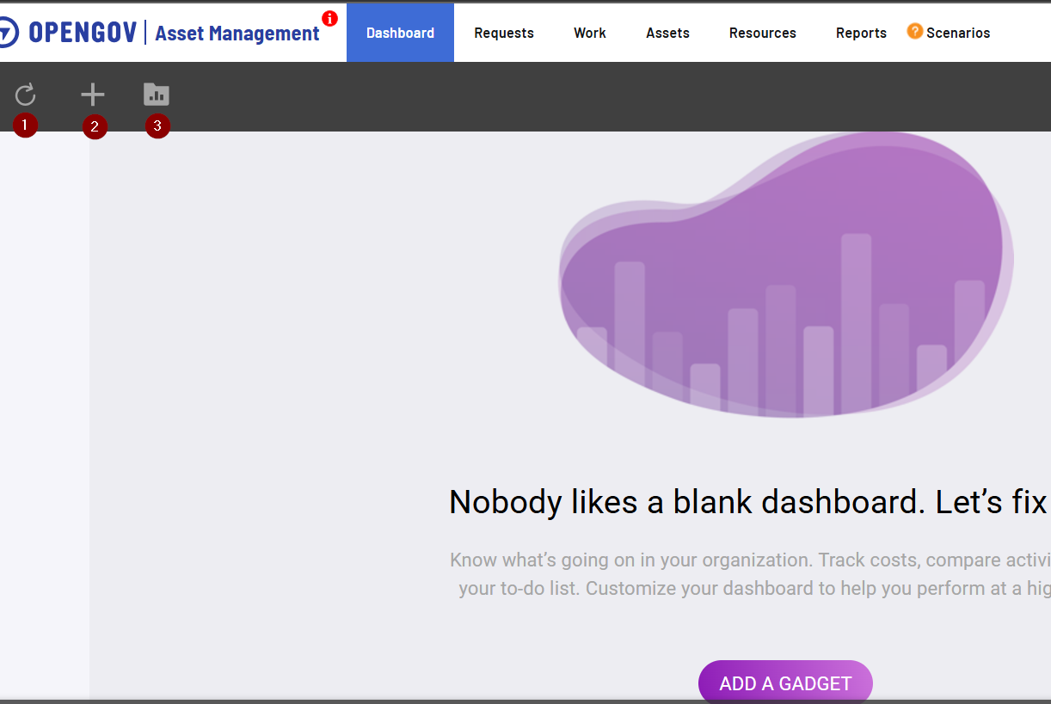

- Refresh all Gadgets – these gadgets use real time data, so this is helpful when wanting/needing to keep track of real time information
- Create a Gadget – additional job aids will be provided or feel free to explore on your own
- Gadget Library – provides access to canned gadgets or custom built gadgets made available to Douglas County. This can be a useful place to start, make copies of existing reports and modify based upon your needs

Requests – web application

General Information
The screen layouts for Requests, Work (Task and Work Order) and Assets is similar. Each layout includes a map with various map tools, ability to Add Layers to the map and provides a List View of the data returns based upon the Layer you have added.
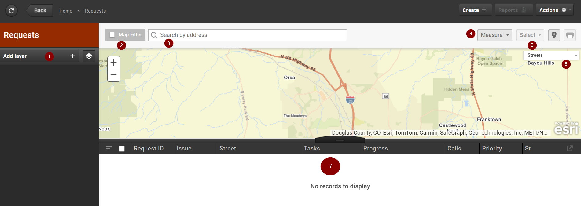
- Add Layer – You can add one to many layers, the initial default is to add “All Requests” and modify from there. Additional information will be provided on creating and modifying Layers
- Map Filter – allows you to limit the results in the List to what is displayed in the map
- Search by Address - This is an ESRI global address search
- Measure – various tools available to use within the map
- Select – various tools available to use within the map
- Base Map selector – You will be able to change the basemap to whatever you prefer. There are a number of ESRI basemaps and Douglas County basemaps available
- List View – this will display the records which meet the Layer(s) you have selected and Filters you have made to each layer
  - The List View can be modified by you in the following methods
    - Move Columns
    - Order 1 to many columns (Tip: If the list is not ordering as you would expect, make sure to look at each column as you may have multiple columns set with an Order)
    - Add/Remove columns – see below screen shot

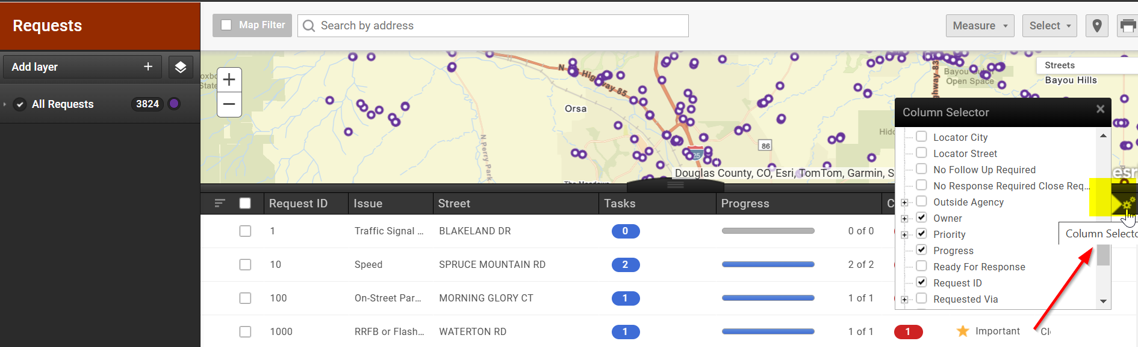

Work – web application

General Information
The screen layouts for Requests, Work (Tasks and Work Order) and Assets is similar. Each layout includes a map with various map tools, ability to Add Layers to the map and provides a List View of the data returns based upon the Layer you have added.
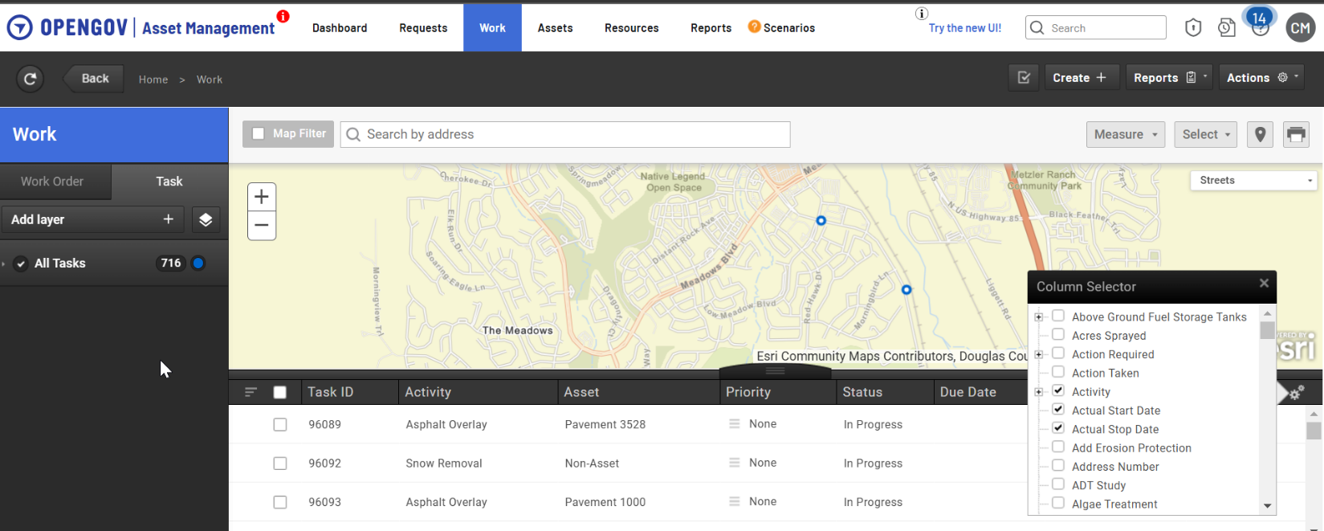

- Add Layer – You can add one to many layers, the initial default is to add “All Tasks” and modify from there. Additional information will be provided on creating and modifying Layers
- Map Filter – allows you to limit the results in the List to what is displayed in the map
- Search by Address - This is an ESRI global address search
- Measure – various tools available to use within the map
- Select – various tools available to use within the map
- Base Map selector – You will be able to change the basemap to whatever you prefer. There are a number of ESRI basemaps and Douglas County basemaps available
- List View – this will display the records which meet the Layer(s) you have selected and Filters you have made to each list
  - The List View can be modified by you in the following methods
    - Move Columns
    - Order 1 to many columns (Tip: If the list is not ordering as you would expect, make sure to look at each column as you may have multiple columns set with an Order)
    - Add/Remove columns – see below screen shot

Assets – web application

General Information
The screen layouts for Requests, Work (Tasks and Work Order) and Assets is similar. Each layout includes a map with various map tools, ability to Add Layers to the map and provides a List View of the data returns based upon the Layer you have added.
See above for some basic information available.
In additions, see below for other features you may find helpful.
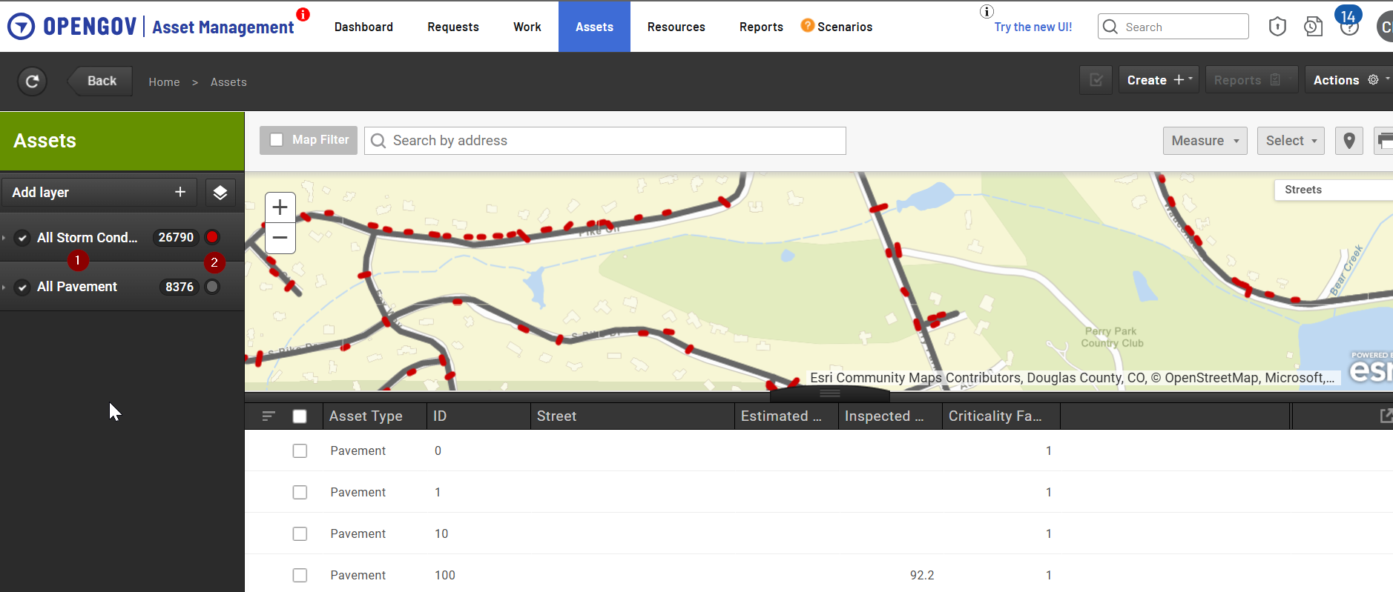

- You can add many different Layers onto the Basemap of your choosing. In the above screenshot, I have added Storm Conduits and Pavement records.
  - Layers can be ordered. In the above example Storm Conduits show up on top of the Pavement records
  - NOTE: When adding Layers of different types (Pavement and Storm Conduits), you will not be able to add or remove any columns as it will only default to the common field elements of Cartegraph.
- You can change the color of each layer by clicking on the color button to the right of the count of records. You will be presented with a Color wheel of all available colors to choose from

Filtering
Filtering records is a core feature of the Cartegraph application and is available throughout the application. It helps you narrow down to the records that you are interested in viewing. Filtering is available for Request records, Work records and Asset records amongst other data sets. Examples of filtering would include items such as “I want to see only Open Requests”, or “I want to see only Tasks completed last month” or “I want to see Storm Ponds maintained by Douglas County”.

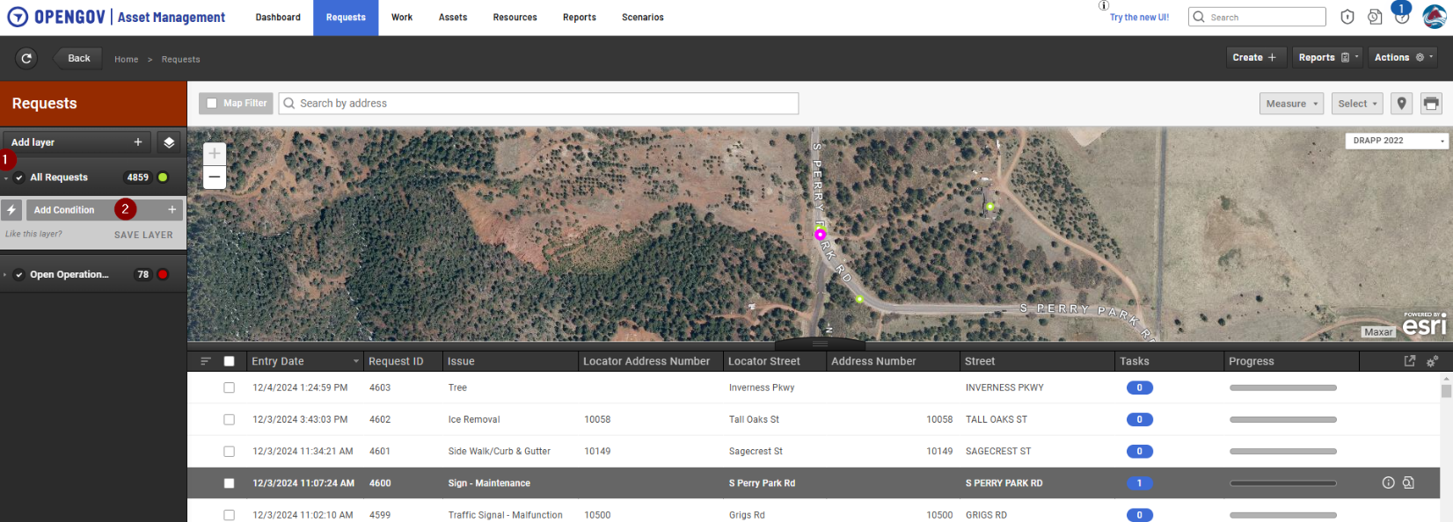

The following steps can be used when creating filters for Requests, Work (Tasks and Work Orders) and Assets.
- Select the small arrow to the left of the Layer you added
- Click on Add Condition
- Select the field you want to Filter on (in this example I am filtering on the Status)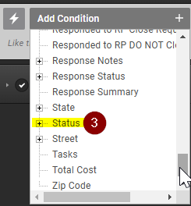
- Select the “Operator” from the drop down
- Select the “Status” from the drop down
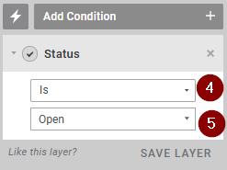

- If this is a Filter you may use often, you can Save the Layer by selecting Save Layer and name it something that makes sense to you. Based upon permissions, you may be able to share the Layer you created to a person or user role.
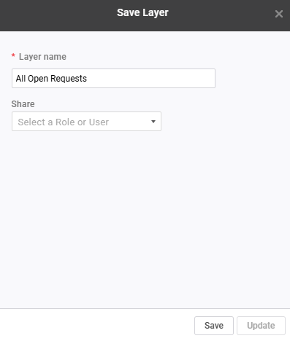

The above example is a basic filtering that can be applied. At times you may need to apply Advanced Filtering.
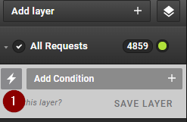
- Select the lightning bolt to the left of the Add Condition
- A new box for entry will open up. In the below example, this filter will show you all Open Requests associated with the Operations department that were created within the last 31 days.
  - NOTE: You may need to change your filtering from “And” to “Or” – do this by clicking on the “And” box.
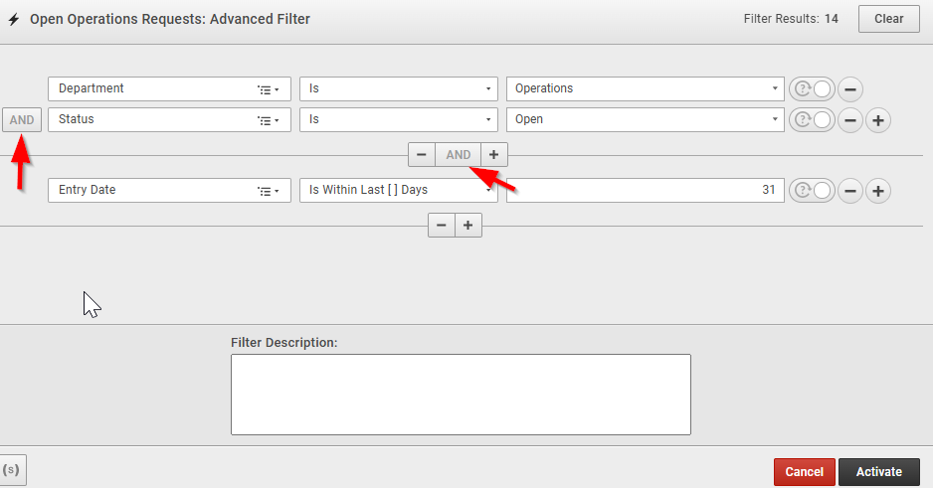

Below are a couple of other examples of using Filters to isolate what you may want to see.
- Pond Inspections Completed after 1/31/2024. This filter was placed within Tasks
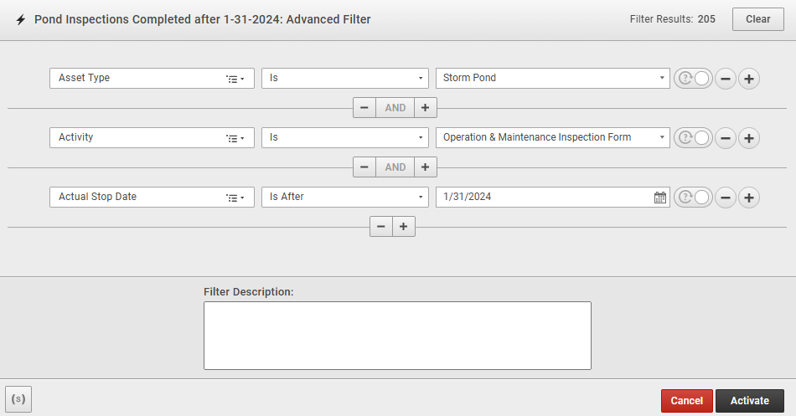

- Concrete Pavement records with an OCI rating between 80 to 89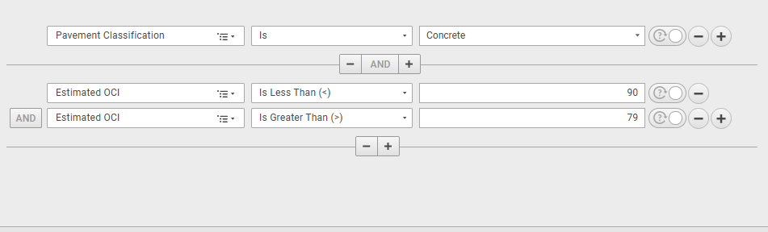

Detail Views
You are able to gain access to additional information related to Requests, Work, and Assets by selecting a record from the List View or from a dot or line on the map.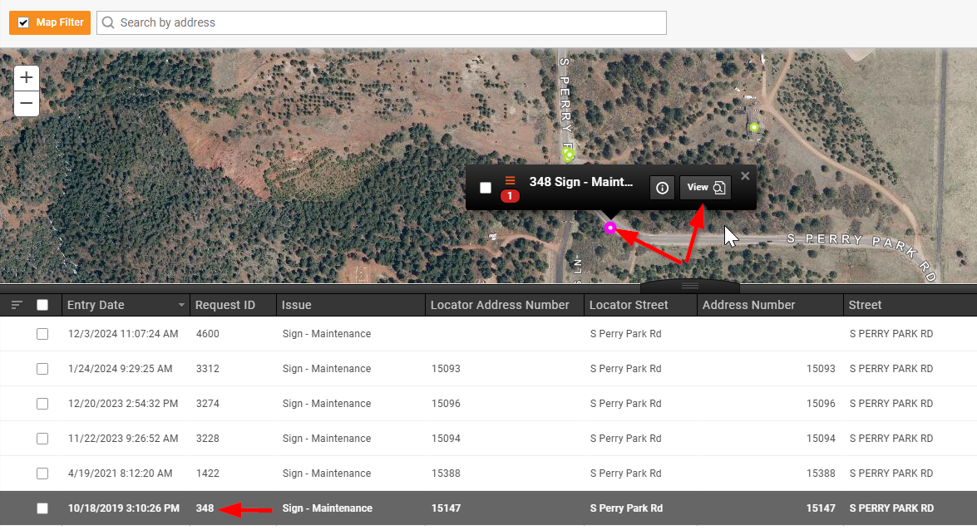

- Click on the dot on the map and then click View or click on the Request ID number in this example
  - NOTE: The link within the list may be something different based upon the type of data you are accessing.

General Information of Detail Views
The best way to learn what is available is by navigating the site on your own, but below are a few examples of the types of information available.

This is an example of a Request Detail view
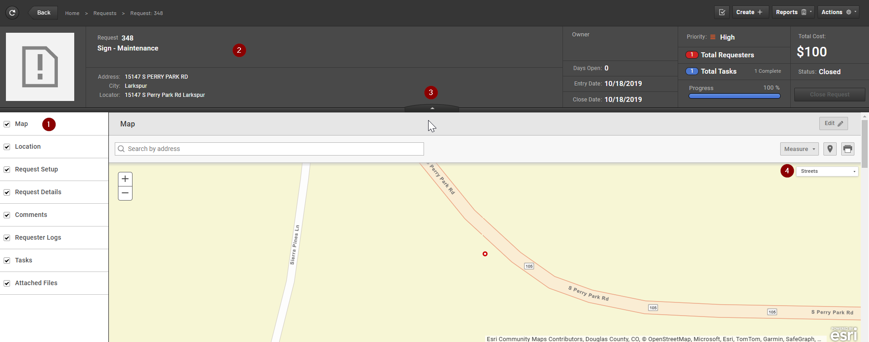

- Items on the left are quick links to different sections within the Detail view
- Headstone (Tombstone) providing some summary information
- The headstone can be collapsed
- Various map tools available – change the basemap or use the measure tools

This is an example of a Task Detail view for a Pond Inspection. Reports were created for some Task types. You can select the Reports button and locate a report you may want to run against a Task.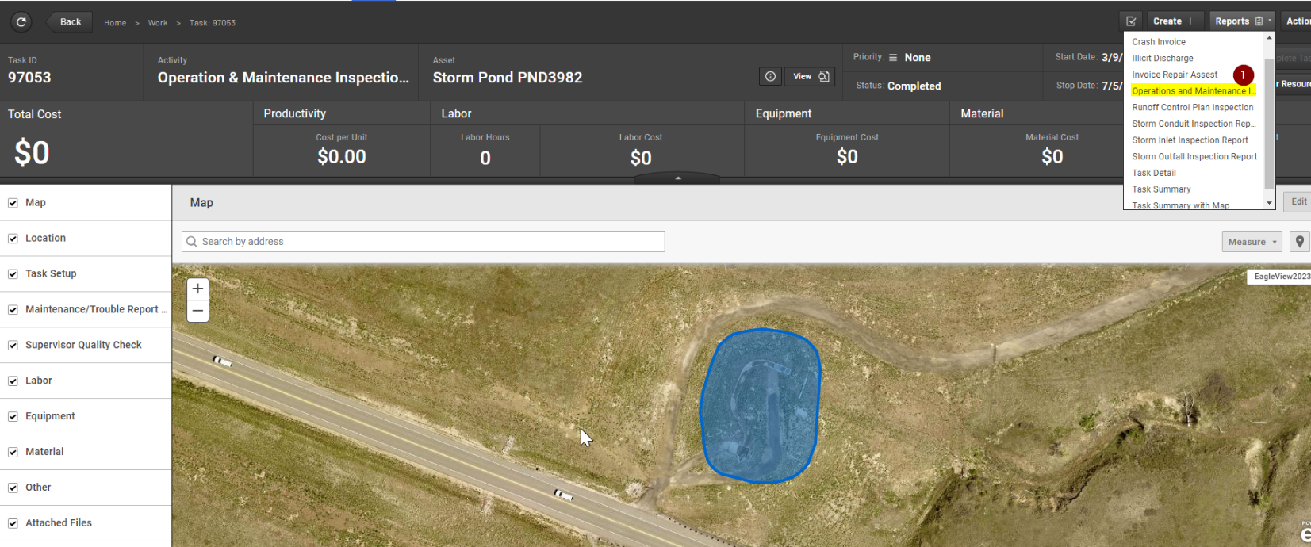

This is an example of a Storm Conduit asset detail view. The County has a few asset types where we have configured Cartegraph to assist in determining a rating of that asset.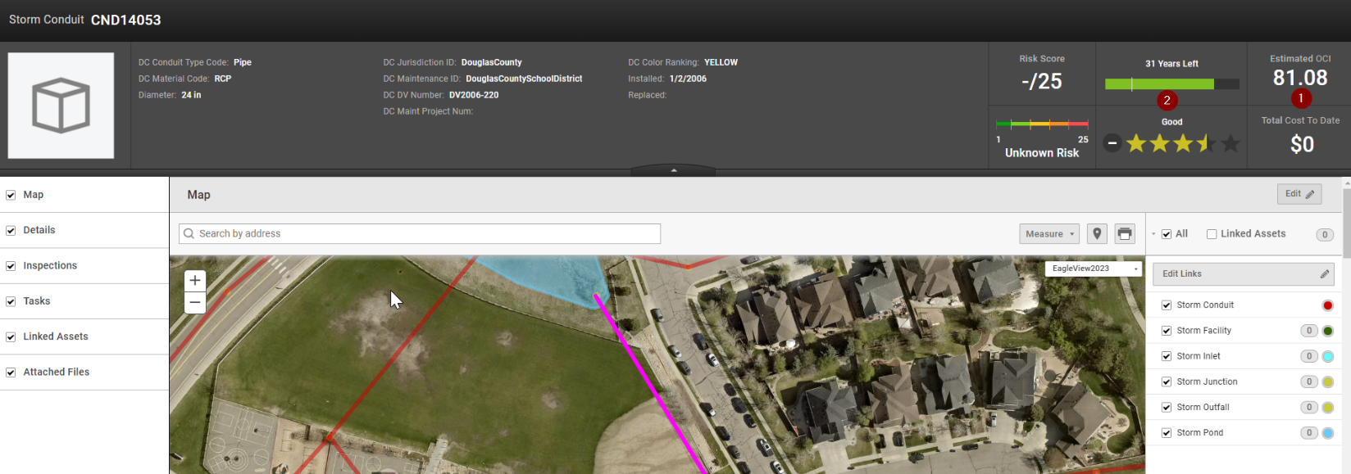
- Estimated OCI (Overall Condition Index). This is on a scale of 0-100
- Provides an estimate of how long we would expect this Conduit to last until it is recommended to be replaced/fixed.

