Bill and Rod,

I have attached some excerpts from the IGA with the City of Aurora which was approved on December 23, 2003.

Bottom Line, this agreement commits the City of Aurora to do maintenance of the full width of Inspiration Drive where it is within the city limits. They do not have the ability to delegate those responsibilities to any other entity except the Metro District. Their area of responsibility will include the new cul-de-sac that they built on the Inspiration right-of-way. The total length of Inspiration Dr. that the City owns is approximately 8965 lineal feet. (3.4 lane miles).

Douglas County maintenance responsibility on Inspiration Drive ends 4 lots (1413 feet) east of Travois Trail, and 1 lot (445 feet) west of Summit Ridge Road.

On the west end, the County snow plows could plow the 1413 feet from Travois Trail east to the Aurora City Limits, then proceed through the roundabout, and come back out westbound to plow in the opposite direction. Total distance to the roundabout and back, is 4400 feet with blade up.

On the east end, it is not as easy. County responsibility ends 445 feet west from Summit Ridge Rd. The next intersection to the west is Woodland Trail which is 4700 feet from the eastern Aurora City Limit. This is approximately 1 mile from Summit Ridge Rd.

No doubt, creates a difficult snow route.

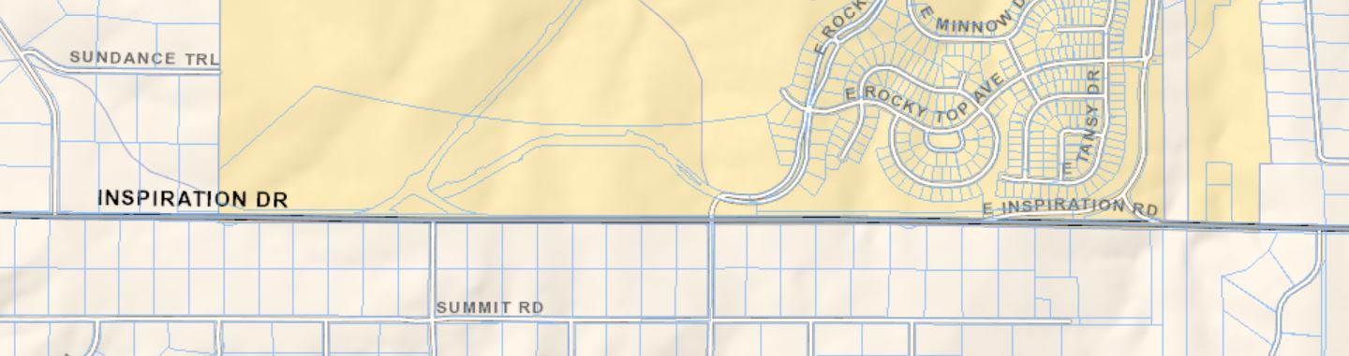

INTERGOVERNMENTAL AGREEMENT BETWEEN THE CITY OF AURORA AND THE BOARD OF COUNTY COMMISSIONERS OF THE COUNTY OF DOUGLAS
and
AGREEMENT BETWEEN GARTRELL INVESTMENT COMPANY, L.L.C.,DEC-COLORADO INVESTMENTS, LLC, THE CITY OF AURORA, AND THE BOARD OF COUNTY COMMISSIONERS OF THE COUNTY OF DOUGLAS.

- DEFINATIONS

County Road 45: means that segment of the public road designated as County Road 45, together with any relocation of the same, and any medians, tum lanes, shoulders, ditches, utility easements, open space, and public rights-of-way associated with the public road (but excluding "Inspiration Drive" as defined in this Section A), which segment is included within the road sections depicted on Exhibits D and attached hereto, and which is located within the unincorporated area of the County and is under the County's jurisdiction

Inspiration Drive: means the segment of the public road commonly known as "Inspiration Drive", also known as County Road 45, that abuts the southern property line of the Gartrell Property, together with any relocation of the same, and any medians, turn lanes, shoulders, ditches, utility easements, open space, and public rights-of-way associated with the public road (but excluding "County Road 45" as defined in this Section A), which segment is included within the road sections depicted on Exhibits D and attached hereto, and which is located within the City's municipal limits and is under the City's jurisdiction.

D. IMPROVEMENTS TO INSPIRATION DRIVE; BUFFER AREA; LOTTING PLAN.
(g) Maintenance of Inspiration Drive.
Upon substantial completion of the Inspiration Drive improvements, Gartrell shall dedicate the improvements to the City, and the City shall accept the dedication of the improvements. The City shall maintain Inspiration Drive, and the improvements thereto described above, according to the street· and road standards applicable to other streets of similar type within the City; provided, however, that the City may contract with the Metro District for the performance all landscaping, trash removal, mowing, and similar maintenance obligations affecting the depressed median within Inspiration Drive.
(h) No Assignment of Obligations.

The City shall maintain possession, jurisdiction, and the obligation to maintain Inspiration Drive and shall not assign or delegate these rights or responsibilities to any person other than the Metro District as contemplated in subparagraph (g) above.

Gary,
Whatever works best for you guys… we will all be here before or after and traveling to you is not an issue either. It may be best to shoot for after next week though being it is shortened..
Tom

From: Gary Walter [mailto:GWalter@douglas.co.us]
Sent: Friday, December 18, 2015 7:25 AM
To: McMinimee, Thomas <tmcminim@auroragov.org>
Cc: Rod Meredith <rmeredith@douglas.co.us>; William Langren <WLangren@douglas.co.us>
Subject: RE: Snow Removal on Inspiration Dr.
Thanks Tom,
Since we are in the holiday season right now, shall we go ahead and schedule a time after the holidays during the week of Jan 4?
Would you like to come here this time? If that does not work for you, we can come your way again.
Just to start the ball rolling, I would like to suggest meeting at the County offices, sometime between 9:00 and 1:00 on Jan 5th.
Thanks,
Gary Walter
Gary Walter, CFM, Project Manager
Douglas County Public Works Operations
3030 North Industrial Way, Castle Rock, CO 80104
Office (303) 660.7480; Fax (303) 841.3319
gwalter@douglas.co.us

From: McMinimee, Thomas [mailto:tmcminim@auroragov.org]
Sent: Thursday, December 17, 2015 6:57 PM
To: Gary Walter
Cc: Rod Meredith; William Langren
Subject: Re: Snow Removal on Inspiration Dr.
Thanks Gary,
We have met internally and have a couple of options. Looking forward to our next meeting.
Sent from my iPhone
On Dec 17, 2015, at 3:44 PM, Gary Walter <GWalter@douglas.co.us> wrote:
Hi Tom,
I am sending this note to follow-up on our Inspiration Drive Snow Removal meeting from November 16th, 2015.
As you probably suspect, in the absence of Auroras’ snow plows and how we can manage our collective approach for snow removal, Douglas County has been removing snow from Inspiration Drive within the city limits of the City of Aurora, even though we collectively recognize and understand that approximately 1.7 miles of Inspiration Drive is within city limits. The snowfall so far this year has been significant, requiring snow removal to facilitate movement of traffic and to keep this route open for emergency services.

In our November meeting you agreed to look at options that we can jointly consider to remedy the Inspiration Drive snow removal dilemma. I am hoping that you might have some considerations that we can discuss to resolve this problem.

For your information, here are some additional facts that we have observed since our last meeting;
- The traffic on inspiration has increased very noticeably…(it is heavy). Please consider the reclassifying this road to a higher level than the current Priority 3.
- Some vehicles are trying to bypass your new round-about by entering the new cul-de-sac, and then driving out the west end of the cul-de-sac to get back onto Inspiration Drive. This is a dangerous movement. It appears that some additional traffic control is needed to deter through traffic in the cul-de-sac.
- The new round-about has a cross pan in it, which I understand is probably a matter of the design that was needed. But it is a very bad design when it comes to snow removal in a round-about. I suspect that there really is nothing that could be done about it now.

Could you please contact Rod Meredith to set up our next meeting, wherein we would hope to conclude our joint plan for snow removal on Inspiration Drive.
Rod Meredith
303-660-7480
Thank you, we are looking forward to meeting with you again as soon as it can be arranged.
Respectfully,
Gary Walter
Gary Walter, CFM, Project Manager
Douglas County Public Works Operations
3030 North Industrial Way, Castle Rock, CO 80104
Office (303) 660.7480; Fax (303) 841.3319
gwalter@douglas.co.us

