2019
Douglas County Budget Department
Revision 1.0
11/1/2019



Mill Levy Certification Application User Guide
Mill Levy Certification Application TOC

Overview 2
Introduction 2
Learning Objectives 2
Authorized User Guidelines 2
Mill Levy Application Navigation 3
Login Screen 3
Landing Page Overview 3
Navigation Overview 5
General Operating Tab 6
Bonds Tab 7
Adding a Bond 8
Adding a Bond continued 9
Deleting or Inactivating a Bond 9
Contracts Tab 10
Adding a Contract 10
The Other Tab 11
Adding Other mill levy to the Other Tab 11
Summary Tab 12
Submit for Certification 13
Not Ready to Submit for Certification 13
Certification Email 14
User Guide Discussion Topics: 15
Bond Tab 15
Explanation of Change 16

Overview

Introduction | The Mill Levy Certification Application was created to streamline the submission of Mill Levies from the Tax Districts to Douglas County Government. The new process is automated and allows you to submit your tax levy information from a secure interface into the Mill Levy Certification Application. You will have the ability to instantly check, validate, and certify your data before submission.

Learning Objectives | At the end of the Mill Levy Application training, you will know how to do the following:  - Login and navigate the application  - Understand the functionality of each tab and how to input data  - Understand how to review the summary tab  - How to certify and submit your Tax Districts Mill Levy  - Share your mill levy confirmation with additional recipients

Authorized User Guidelines | To gain access to the application, each Tax Districts will fill out and submit the “Mill Levy Entry Authorization Form” to Douglas County’s Budget Department. Once Authorized, the user will receive an email with their login credentials and a link to the application.  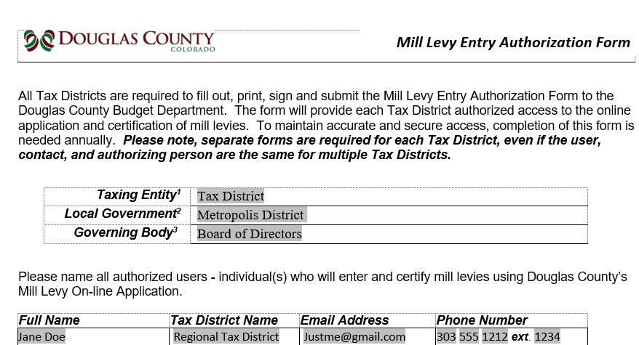  Authorized Users will have the ability to:  - Input mill levies into a secure application  - Review the auto populated information from last year’s Mill Levy submission  - Review and add additional Bonds, Contract and Judgements  - Certify and Submit your Tax District’s mill levies

Mill Levy Application Navigation

Login Screen | After successfully submitting your “Mill Levy Entry Authorization Form”, you will receive an email with the login instructions and a link to access the application.  - Input User ID and Password  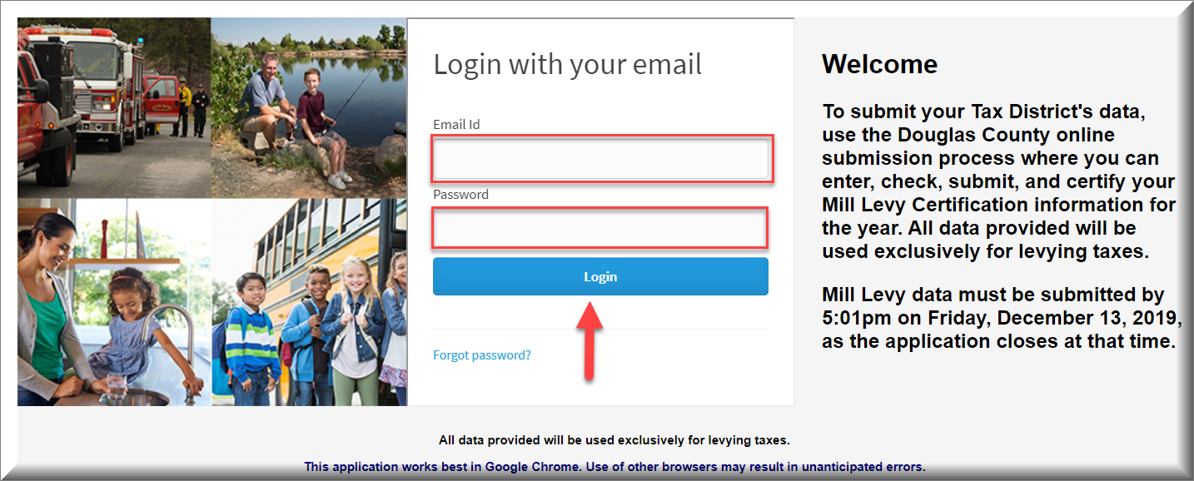

Landing Page Overview | The Landing Page Screen  This is a read only screen, so you will not have the ability to update this screen  - Start by selecting your Tax District.  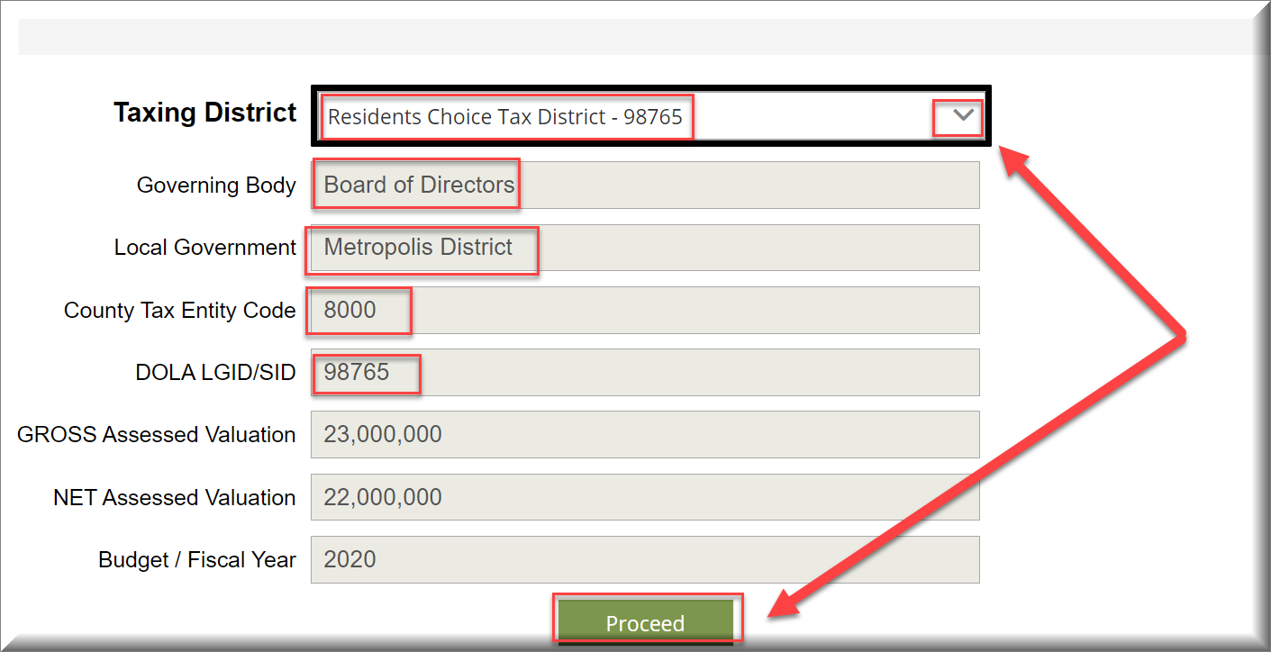  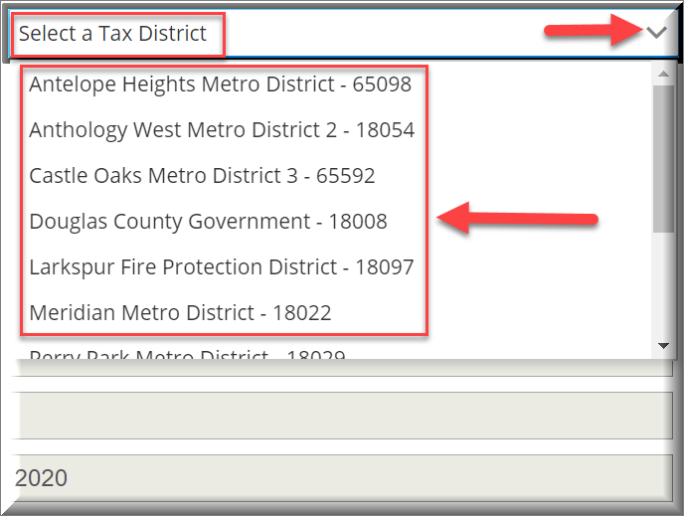  Note: If you have access to multiple Tax Districts, the drop down will display additional selections. Most authorized users will have access to one Tax District.  After selecting your Tax District from the drop-down field, the Gross & Net assessed valuation for current year will auto populate. You will also see the Governing Body, Local Government, County Tax Entity Code, DOLA LGIF/SID and the Budget/Fiscal Year auto populated as well.  - Click Proceed to enter your Mill Levy data  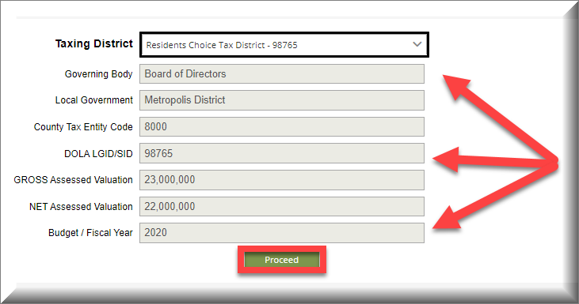  The information appearing on the Landing Page is taken from the corresponding fields in the Mill Levy Entry Authorization Form and from the Assessor’s System.  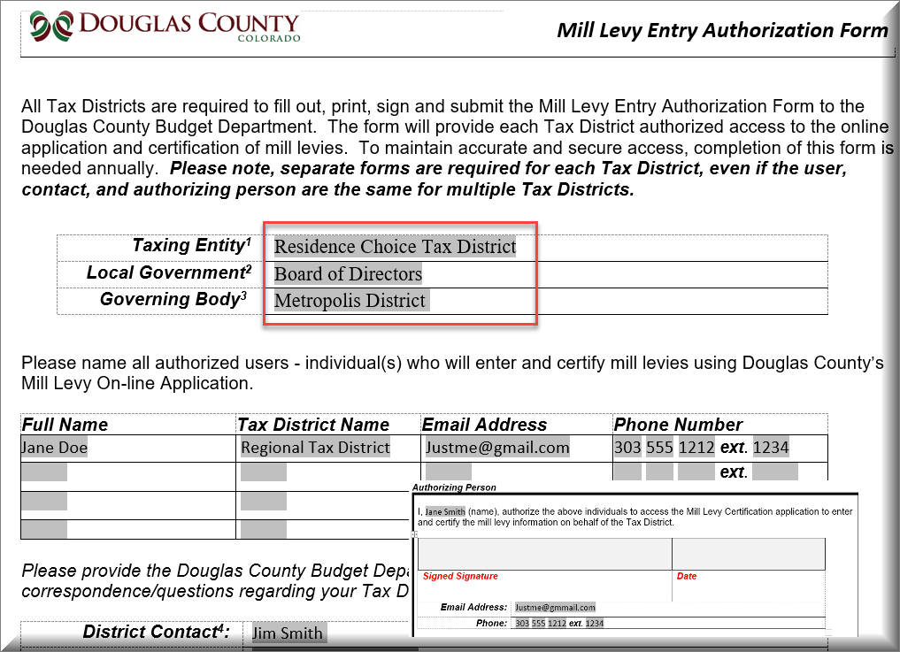

Navigation Overview | Let’s review and discuss each tab of the Mill Levy Certification Application.  Helpful Tip: Have a copy of your completed DLG 70 form for reference as we review each tab.  Screen Navigation: Use the screen caption below to learn about each section.  - Tax District is visible as you update each tab.  - Tabs will light up “Green” as you navigate through each one.  - Mill Levy fields are updatable so you can add data from the DLG 70 form.  - The Switch Tax District link allows you to go back to the Tax District screen. This feature allows you to select additional tax districts assigned to you.  - If you have already updated the tabs from a previous session, then you can select “Jump to Summary” to review your submissions in the “Summary” tab.  - The “Next” button allows you to navigate to the next Tab or you can select the Tab you wish to update.  - The “Logout” button can be selected after you have completed your updates or certified your submission.  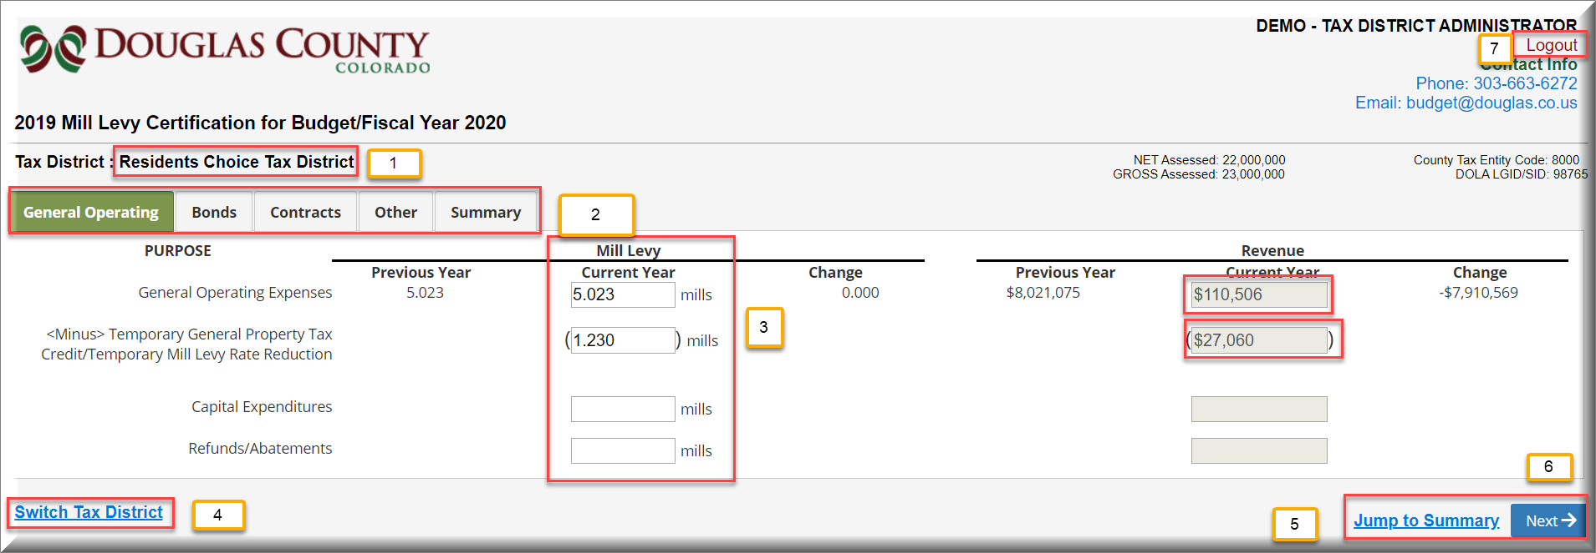  Notable Feature: The Mill Levy Certification Application auto saves your information as you update each field. So, there is no need to save after each update.

General Operating Tab | The General Operating Tab  The General Operating Tab is where you will input this year’s mill levy and review the mill levies from the previous year.  Let’s use the numbers below to review each field within this tab.  - Previous Years Mill Levy: Will auto populate from last year  - Current Year Mill Levy: You will need to add the mill levy  - Tax Credits: Example “TABOR” –You will need to add any tax credits. The parenthesis around the numbers entered will designate it as a negative number, so you will not need to enter a minus (-), (1.230) is a negative number  - Previous Years Revenue – will auto calculate  - Current Years Revenue minus Tax Credit – will auto calculate  - Capital Expenditures – Example: Funding to purchase Fire Engines  - Refund/abatements – Abatement Recovery Mill Levy
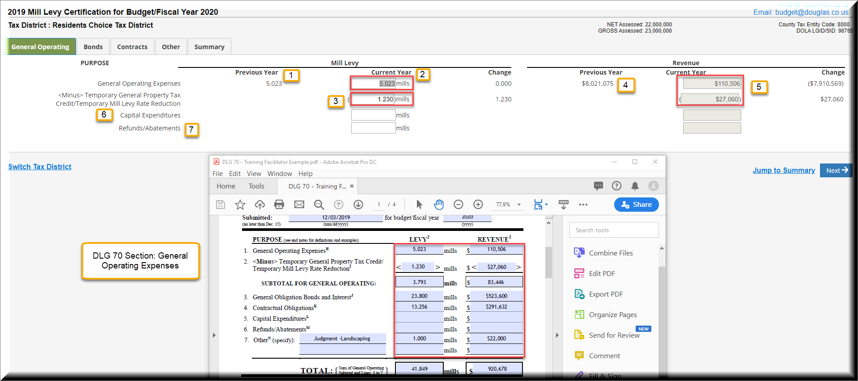

Bonds Tab | The Bonds Tab allows you to review bonds from the previous year and add a new bond for the current year.  - You can review the Purpose of Issue as listed on your DLG 70 form  - You can review the Mills for the Current Year  - You can add new Bonds by selecting the Add button
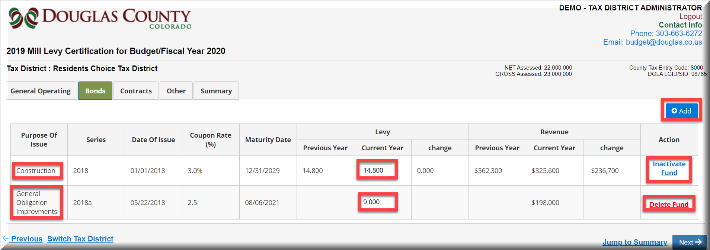

DLG 70 Page 2 | 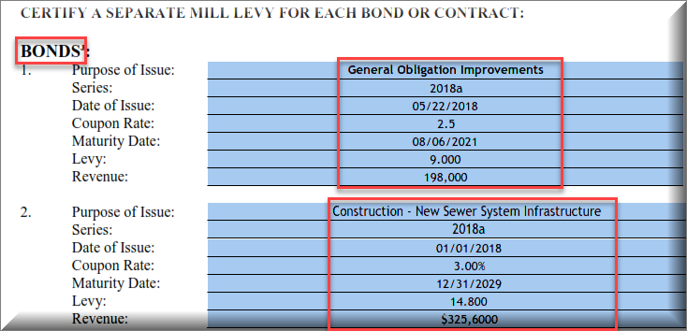

Adding a Bond | If you need to add a new Bond for this year, then click on the “Add” button.  After selecting “Add” a new screen will open so that you can add the new Bond information. The required fields will have an (*) and there will be different required fields for “Issued” & “Proposed”.  Follow the steps below:  - Select the Add button to add a new Bond  - Select “Proposed” or “Issued”  - Proposed Bonds: Is a Bond in process that has not been officially issued  - Issue Bonds: Is a current bond  - Update the purpose of issue  - Add a Series: Usually the year of issue and possibly a letter “A” or “B”  - Add the date of issue  - Add the maturity date  - Add the levy amount  - The Revenue will automatically calculate  - Select “Add” to save it to the Tab  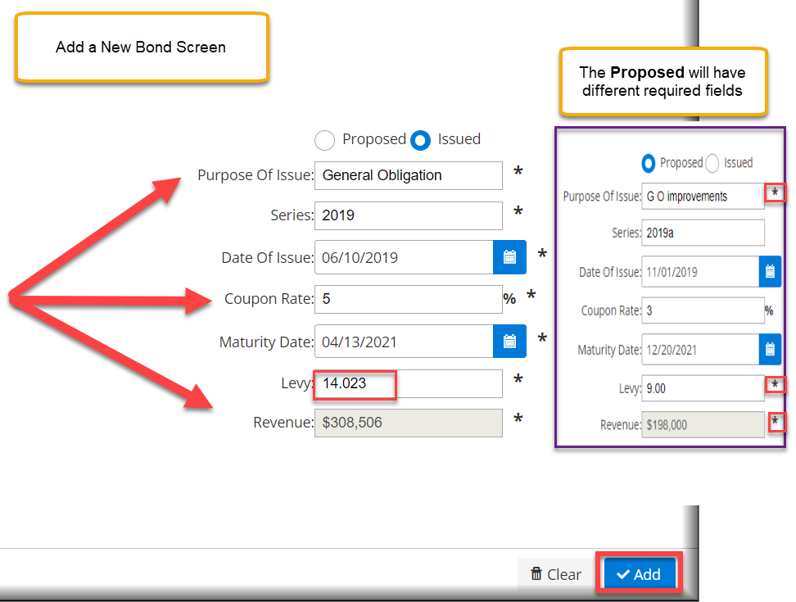

Adding a Bond continued | The New Bond will display within the Bond tab  - Review the new updated Bond information  - Compare the new Bond information with your DLG 70 form

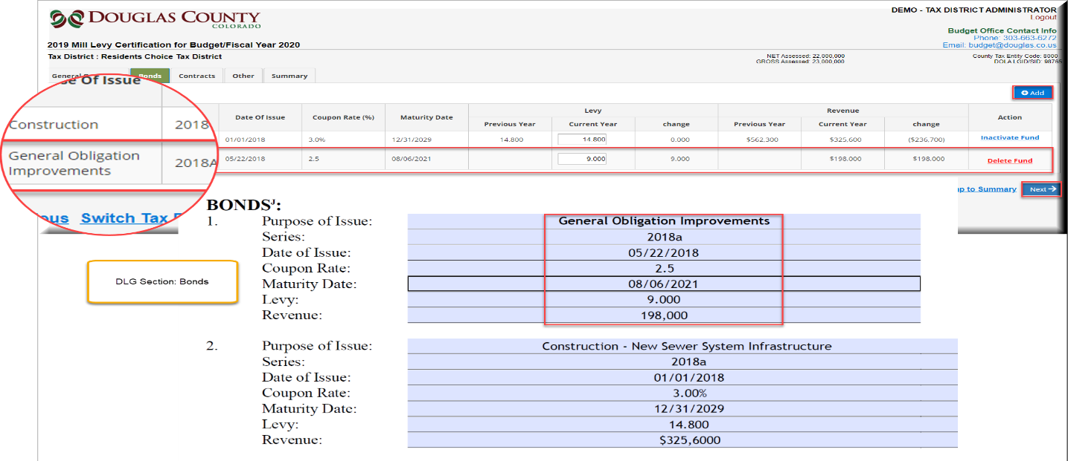

Deleting or Inactivating a Bond | Bonds can be inactivated or deleted within the Bonds tab.  If the Bond information was inputted incorrectly then select “Inactivate Fund” If the Bond has reached its Maturity Date, then select “Inactivate Fund” to remove the Bond. If you inputted the incorrect data within the new Bond, then you can select “Delete Fund” and then then follow the Add Bond process again.  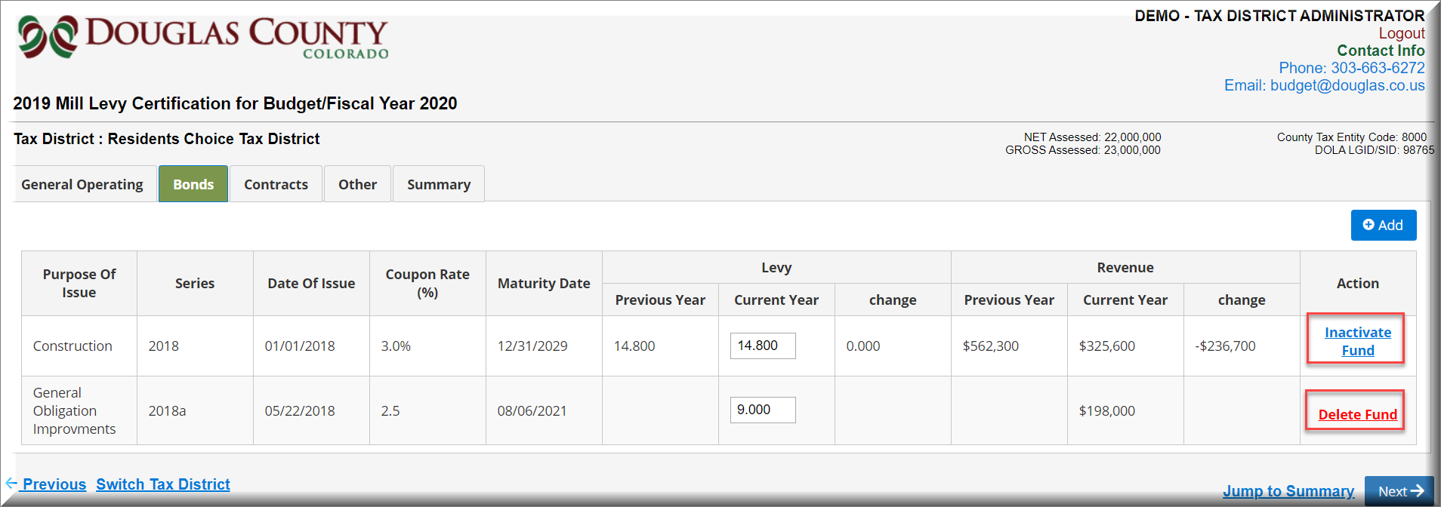  Select “Inactivate” or “Delete” and the Bond will be deleted from the screen  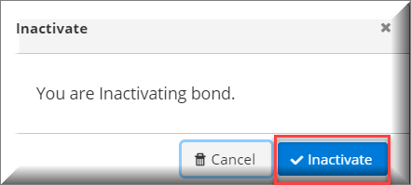  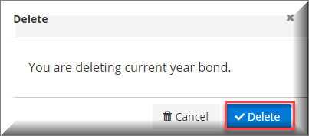

Contracts Tab | The Contracts Tab allows you to review the Contracts from the previous year and add a new contract for the current year.  - The Purpose of Issue is listed in the first Column  - The Current Year Levy is listed with the Mills – Add your new Mills  - The revenue for the Current Year is listed in the Revenue Column  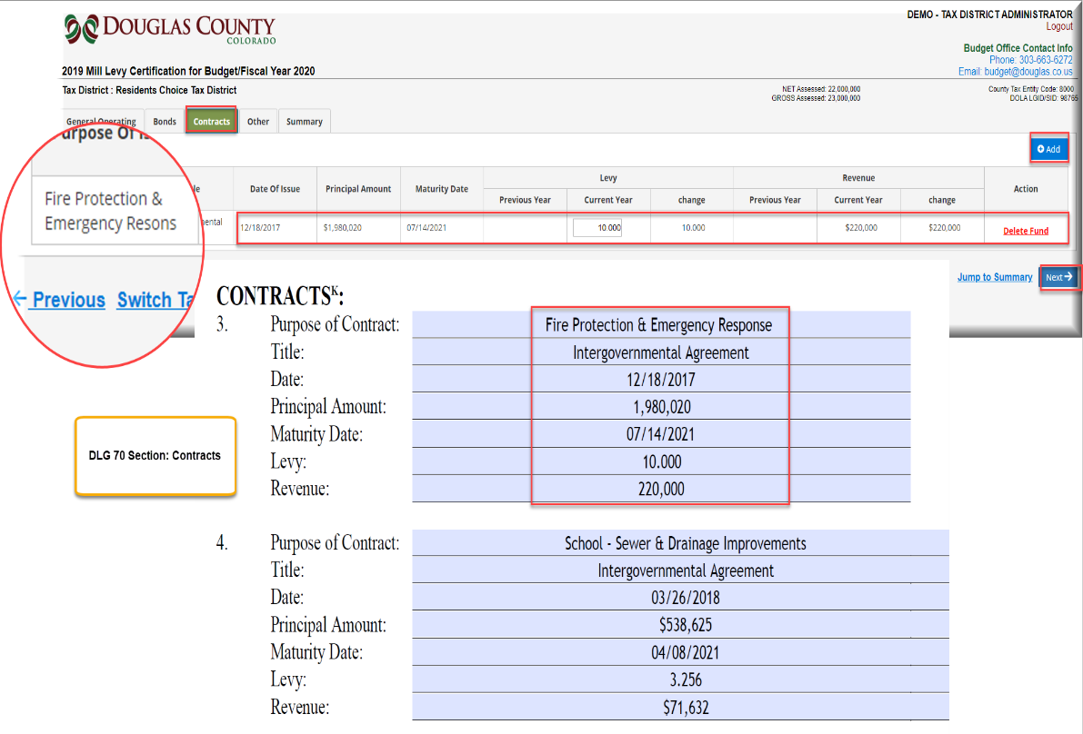

Adding a Contract | Like the Bonds Tab, you can Add a Contract for the Current Year and Delete a Contract that was entered incorrectly. Contracts that have reached their Maturity date can also be inactivated.  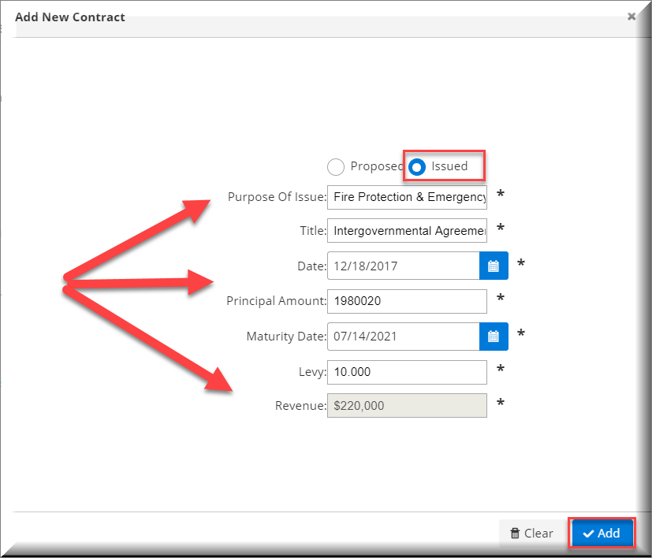  - Follow the same steps for Inactivate and Deletions as you followed for Bonds.

The Other Tab | The Other Tab allows you to view Other mill levies from the previous year and the mills associated with them. You can also add new Other mill levies as we discussed in the Bonds and Contracts Tabs.
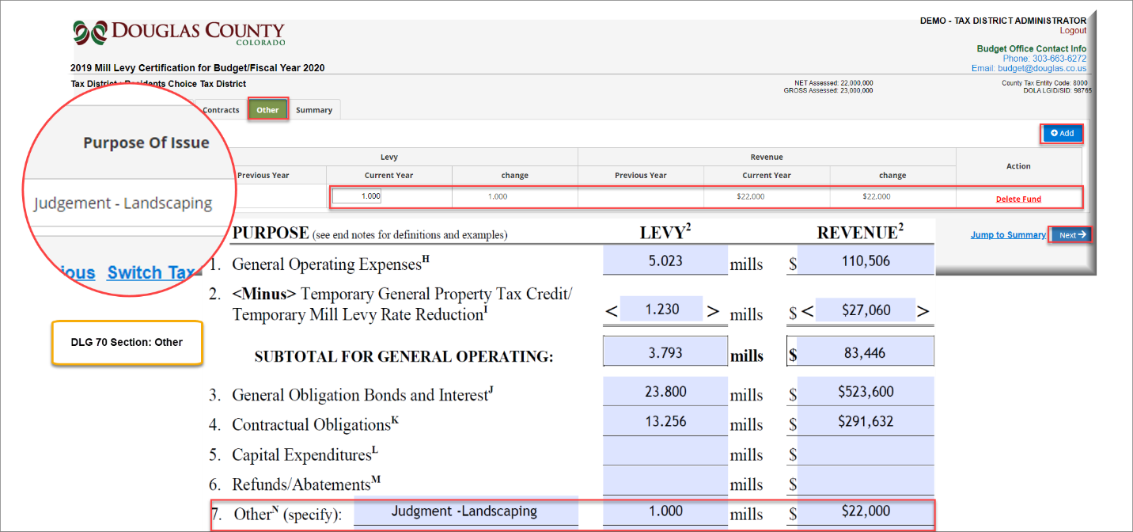

Adding a mill levy to the Other Tab | To add an “Other mill levy” to the Other Tab  - Click on Add  - Update the Purpose  - Add the Levy  - Click on Add  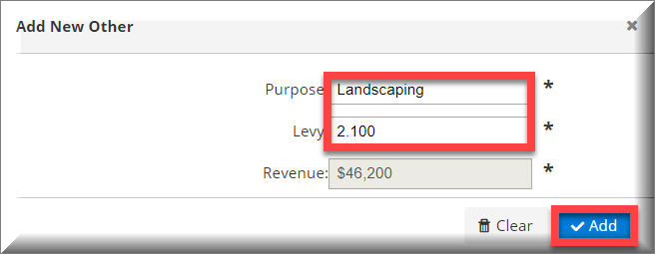

Summary Tab | The Summary Tab allows you to review your Mill Levy data entry before submitting for Certification  - Your updated Mill Levy data is displayed below the “Mill Levy” column.  - You can review the Revenue for the Current year.  - You can see the changes from the previous and current years Revenue figures.  - If you find the data is incorrect, select the “Previous” Link at the bottom of screen and go back to that tab and correct it.  - If there was a change to the Mill Levy from the previous year, then you may enter an explanation for the change in the” Explanation of Change” field.  - If everything is correct, select the “Submit for Certification” button.

Submit for Certification | After selecting “Submit for Certification” from the Summary Tab, you will complete the following steps:  - Enter any additional email addresses who should receive the certification email.  - Review the disclosure documentation.  - Select the “Certify” button to submit this Year’s Mill Levy to the Douglas County Government.  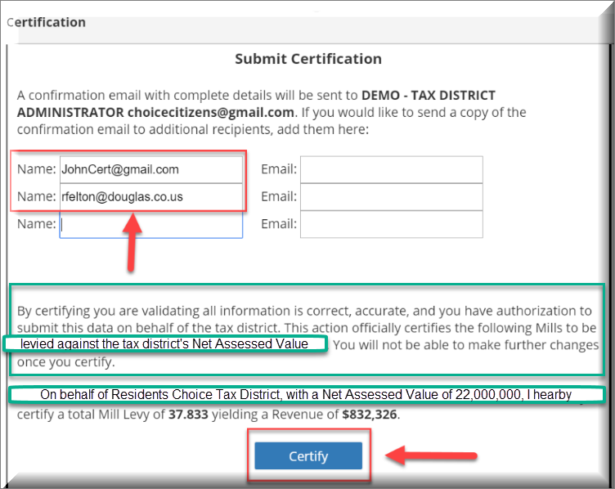

Not Ready to Submit for Certification | When accessing the Submit for Certification screen and you’re not ready to certify:  - Select the following link: To return to the Summary Tab.  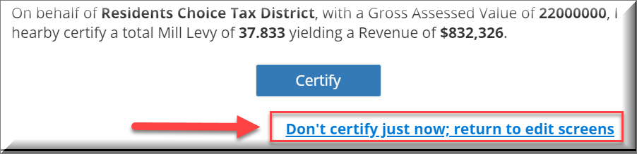

Certification Email | After Successfully submitting your Mill Levy for Certification, you will receive a Confirmation Email.
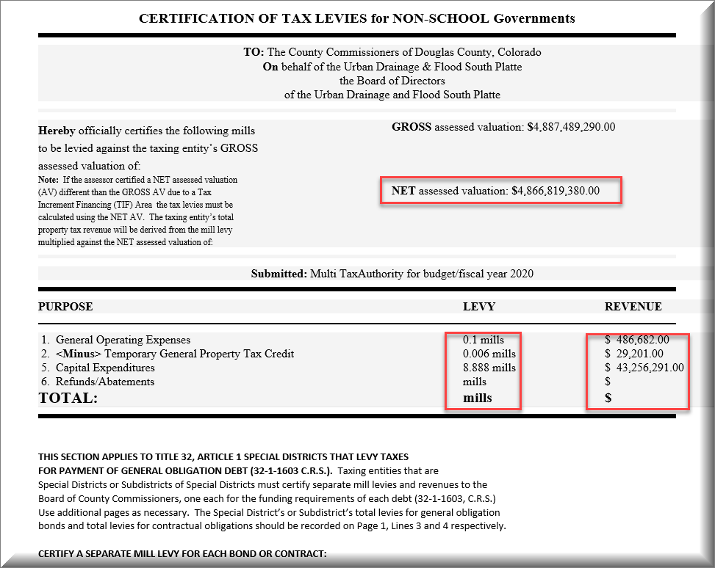

User Guide Discussion Topics:
Bond Tab | Some of the Tax Districts have provided a single Mill Levy for items that may have multiple funds associated.  There are examples of Tax Districts that have enter 2 bonds on their DLG 70 form with Bond (A) listed as 7.000 mills and Bond (B) listed as 0.000mills.  - The total Mill Levy is 7.000  We recommend you follow the example below when entering the Mills into the Application:
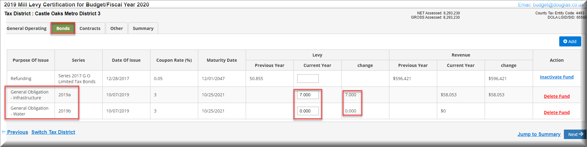

Explanation of Change | After adding the new bonds to the Bond Tab, please access the Summary Tab and add an explanation to the “Explanation of Change” Field  - The Bond Mills for 2018a and 2018b are 2 separate mills that have been calculated and the sum was inputted into the 2018a Bond as 7.000 mills.  