Mill Levy Certification Application User Guide 2021
User’s Guide
Userguiode
2021


Douglas County Budget Department
Revision 2.0
10/15/2021

Mill Levy Certification Application TOC

Overview 2
Introduction 2
Learning Objectives 2
Authorized User Guidelines 2
Mill Levy Application Navigation 3
Login Screen 3
Landing Page 3
Authorization Form 5
Navigation Overview 5
General Operating Tab 6
Bonds Tab 7
DLG 70 Page 2 7
Adding a Bond 8
Adding a Bond continued 9
Deleting or Inactivating a Bond 9
Contracts Tab 10
Adding a Contract 10
The Other Tab 11
Adding a mill levy to the Other Tab 11
Judgment Tab 12
Summary Tab 13
View Draft 14
Submit for Certification 15
Not Ready to Submit for Certification 15
Certification Email 16
User Guide Discussion Topics: 17
Bond Tab 17
Explanation of Change 18

Overview

Introduction | The Mill Levy Certification Application was created to streamline the submission of Mill Levies from the Tax Districts to Douglas County Government. The process is automated and allows you to submit your tax levy information from a secure interface into the Mill Levy Certification Application. You will have the ability to instantly check, validate, and certify your data before submission.

Learning Objectives | At the end of the Mill Levy Application training, you will know how to do the following:  - Login and navigate the application  - Understand the functionality of each tab and how to input data  - Understand how to review the summary tab  - How to certify and submit your Tax Districts Mill Levy  - Share your mill levy confirmation with additional recipients

Authorized User Guidelines | To gain access to the application, each Tax Districts will fill out and submit the “Mill Levy Entry Authorization Form” to Douglas County’s Budget Department. Once Authorized, the user will receive an email with their login credentials and a link to the application.  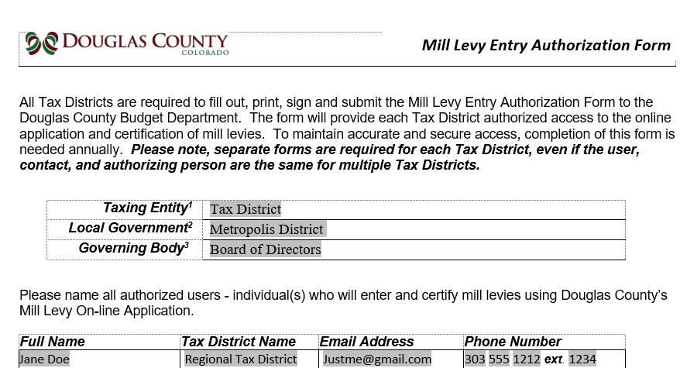  Authorized Users will have the ability to:  - Input mill levies into a secure application  - Review the auto populated information from last year’s Mill Levy submission  - Review and add additional Bonds, Contract and Judgments  - Print a draft of all mill levies entered before certification  Certify and Submit your Tax District’s mill levies

Mill Levy Application Navigation

Login Screen | After successfully submitting your “Mill Levy Entry Authorization Form”, you will receive an email with the login instructions and a link to access the application.  - Input User ID and Password and click “Login” to access the app  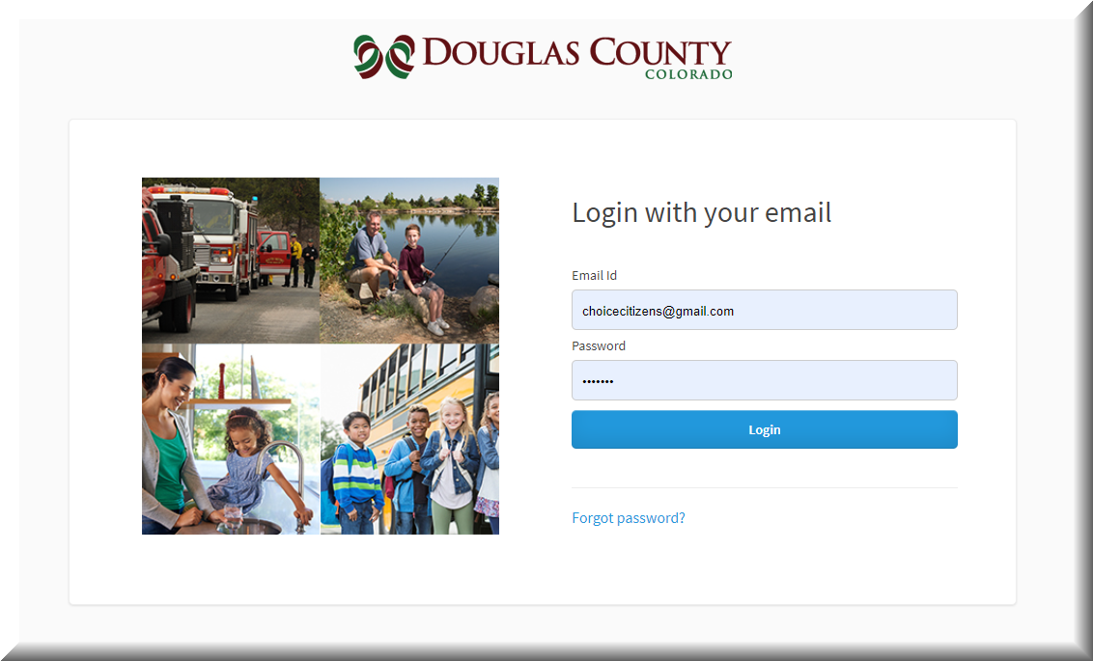

Landing Page | The Landing Page Screen  Select your Tax District  - Before you begin, you will have the option to filter the district status’s (Not Started…ect),If you have access to additional tax districts then select All to see the districts.  - Status: Not started, In progress – completed updates within app, Certified – When Submitted,  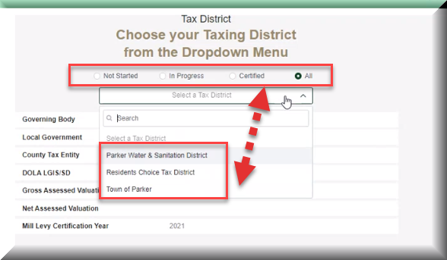  - Click on the Drop Down arrow and select the Tax District,  - After selecting your Tax District from the drop-down field, the Gross & Net assessed valuation for current year will auto populate. You will also see the Governing Body, Local Government, County Tax Entity Code, DOLA LGIF/SID and the Budget/Fiscal Year auto populated as well.  - The app will bring in the Gross and Net Assessed values, Select “Data Entry”to move to the General Operations Scree  +  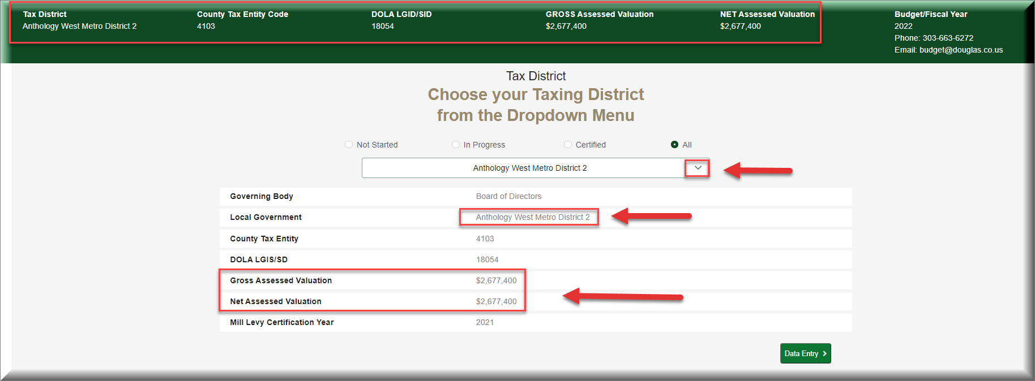  Note: If you have access to multiple Tax Districts, the drop down will display additional districts authorized to access. Most authorized users will have access to one Tax District.  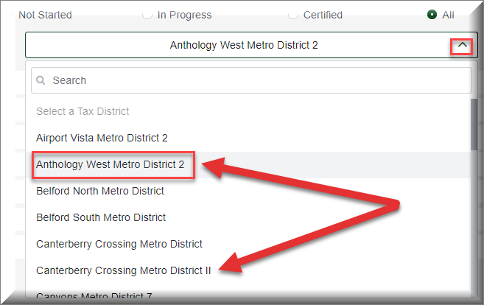

Authorization Form | The information appearing on the Landing Page is taken from the corresponding fields in the Mill Levy Entry Authorization Form and from the Assessor’s System  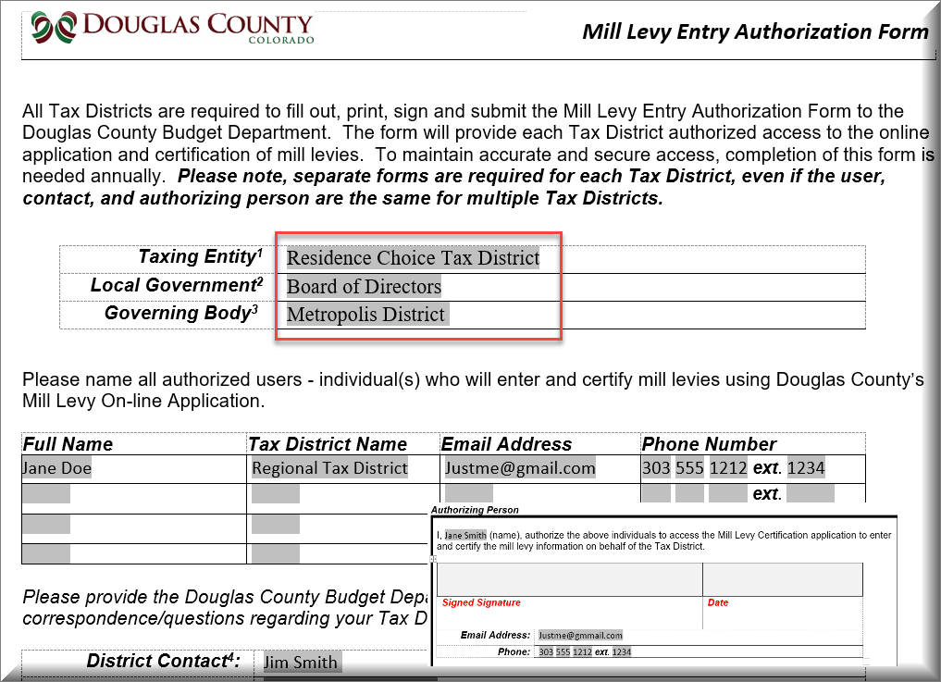

Navigation Overview | Let’s review and discuss each tab of the Mill Levy Certification Application.  Helpful Tip: Have a copy of your completed DLG 70 form for reference as we review each tab.  Screen Navigation:  The Process Arrows will display which Certification phase you’re in and the Process Steps will display step you in within the certification process. Each Process step will have Process Task that must be completed to transition to the next screen.  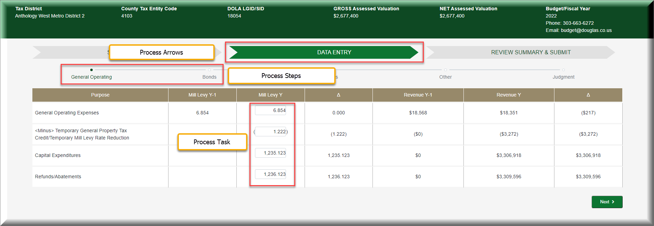  Notable Feature: The Mill Levy Certification Application auto saves your information as you update each Process Task. So, there is no need to save after each update.

General Operating Tab | The General Operating Tab  The General Operating Tab is where you will input this year’s mill levy and review the mill levies from the previous year.  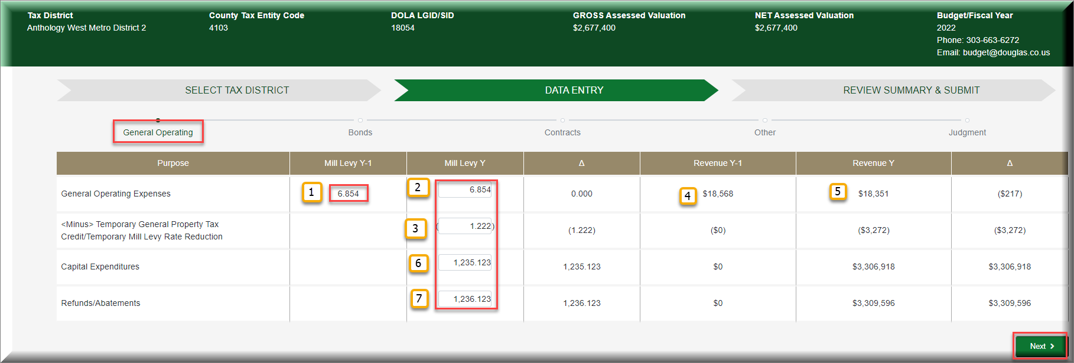  Let’s review the processes within the screen. numbers to review the General Operating Tab layout in the example below.  - Previous Years Mill Levy: (Mill Levy Y-1) Will auto populate from last year’s Mill Levy  - Current Year Mill Levy: (Mill Levy Y) You will need to add the mill levy, to red boxed fields.  - Tax Credits: You will need to add any tax credits. The parenthesis around the numbers entered will designate it as a negative number, so you will not need to enter a minus (-), (1.230) is a negative number  - Previous Years Revenue – will auto calculate  - Current Years Revenue minus Tax Credit – will auto calculate  - Capital Expenditures – Example: Funding to purchase Fire Engines  - Refund/abatements – Abatement Recovery Mill Levy

Bonds Tab | The Bonds Tab allows you to review bonds from the previous year and add a new bond for the current year.  - You can review the Bond Type: Issued or Proposed  - You can review the Purpose of Issue as listed on your DLG 70 form  - You can review the Mills for the Current Year – you will be required to input the mills.  - You can add new Bonds by selecting the Add Line link  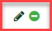  - You can Edit an issued Bond by clicking on the Pencil icon and  - You can activate or inactivate a bond by clicking the circle  - You can Delete Proposed Bonds from within the “Action Column” by clicking on the Trash Can
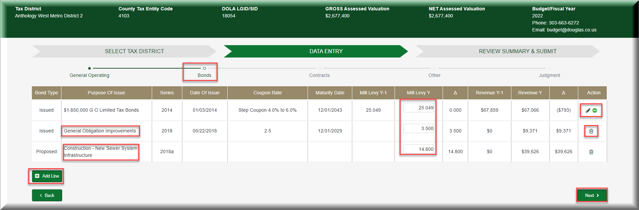

DLG 70 Page 2 | 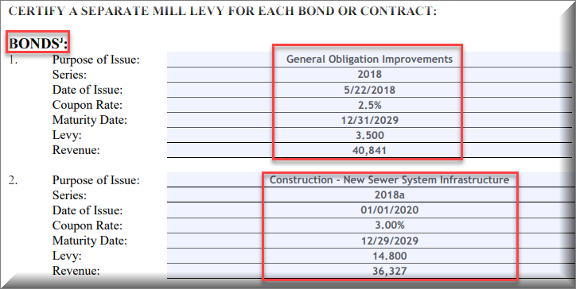

Adding a Bond | If you need to add a new Bond for this year, then click on the “Add Line” button.  After selecting “Add Line” a new screen will open so that you can add the new Bond information. The required fields will have an (*) and there will be different required fields for “Proposed” & “Issued”.  Follow the steps below:  - Select the Add button to add a new Bond  - Select “Proposed” or “Issued”  - Proposed Bonds: Is a Bond in process that has not been officially issued  - Issue Bonds: Is a current bond  - Update the purpose of issue  - Add a Series: Usually the year of issue and possibly a letter “A” or “B”  - Add the date of issue (MM/DD/YYYY)  - Add the Coupon rate  - Add the maturity date (MM/DD/YYYY)  - Add the levy amount  - The Revenue will automatically calculate  - Select “Add” to save it to the Tab  Proposed: Only Purpose of issue & Levy are required; other information will be entered next year after the bond is issued
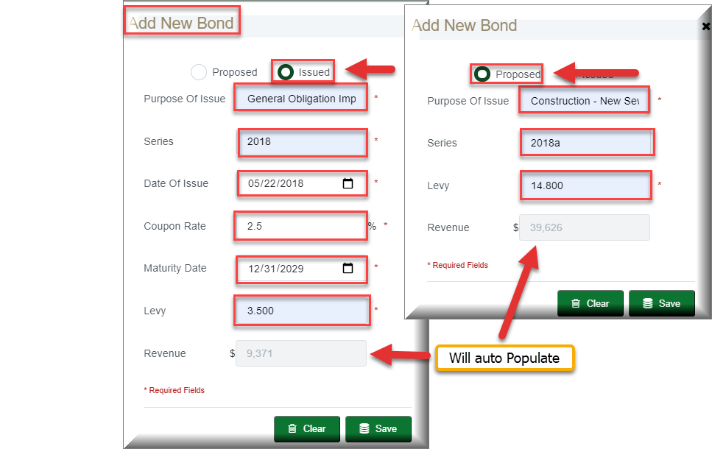

Adding a Bond continued | The New Bond will display within the Bond tab  - Review the new updated Bond information  - Compare the new Bond information with your DLG 70 form
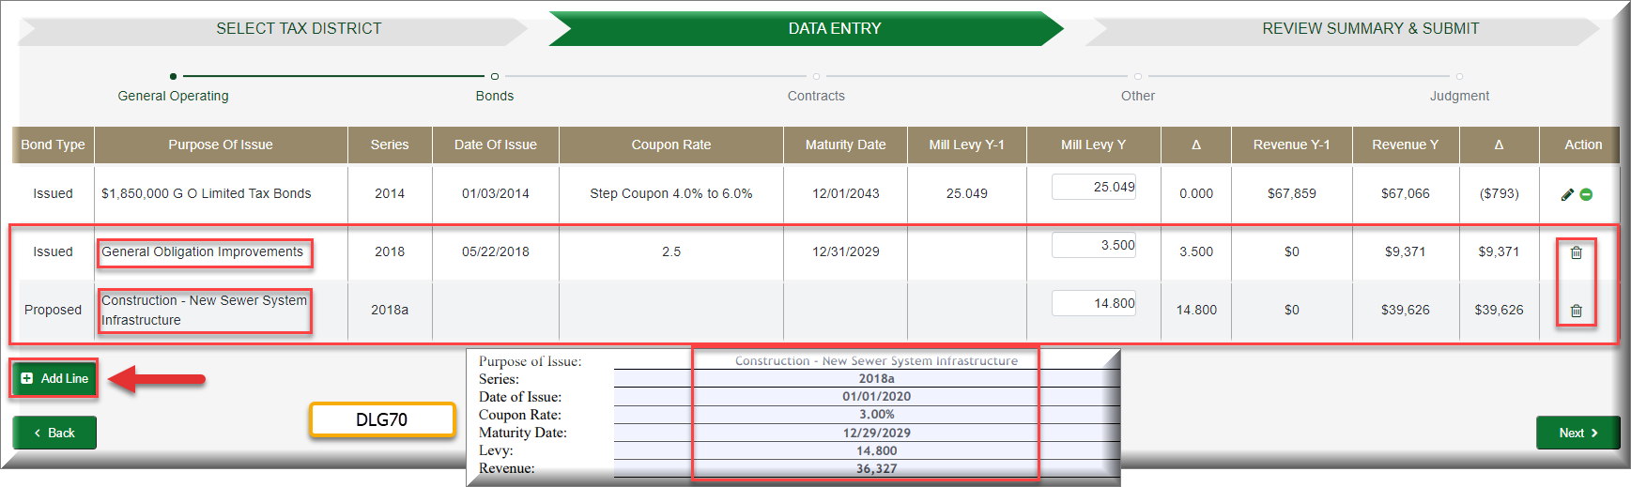

Deleting or Inactivating a Bond | Bonds can be inactivated, edited, or deleted within the Bonds tab. If the Bond information was inputted incorrectly then select “Edit Bond Description” If the Bond has reached its Maturity Date, then select “Inactivate Fund” to remove the Bond. If you inputted the incorrect data within the new Bond, then you can select “Delete Fund” and then follow the Add Line Bond process again. Bonds can also reactivated.
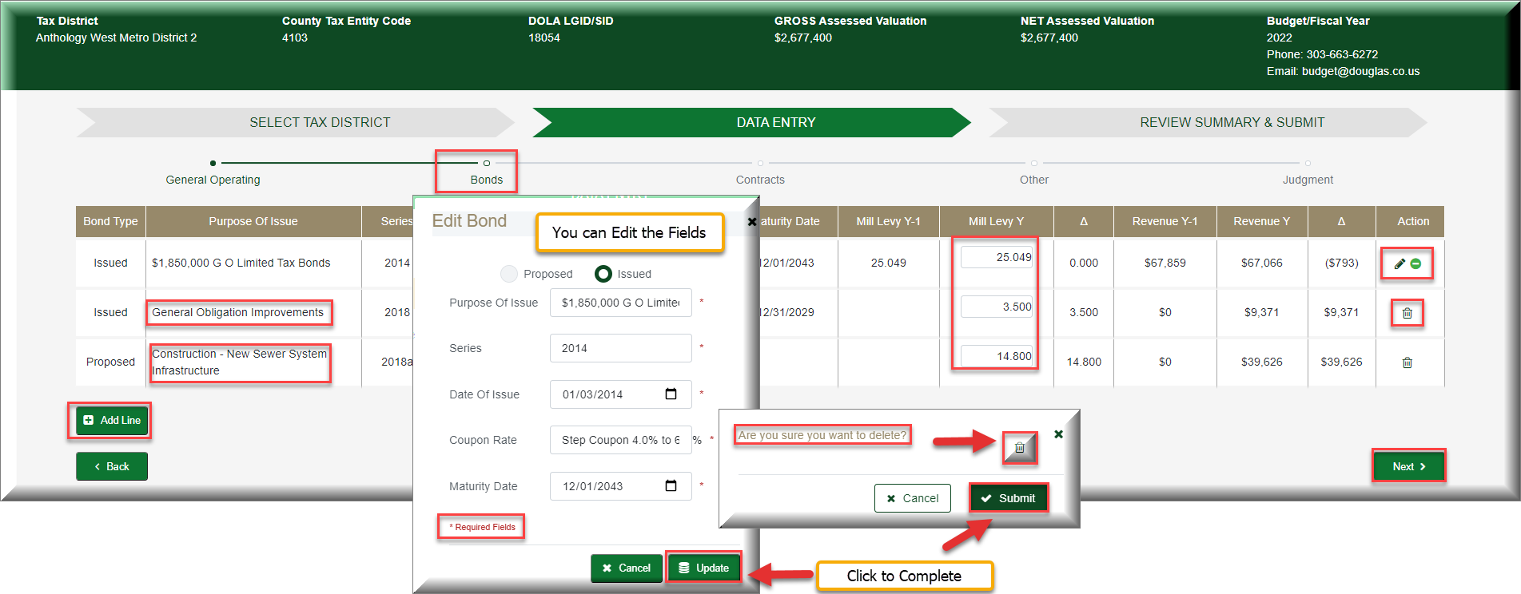

Contracts Tab | The Contracts Tab allows you to review the Contracts from the previous year and add a new contract for the current year. You can also inactivate, edit, or delete a contract.
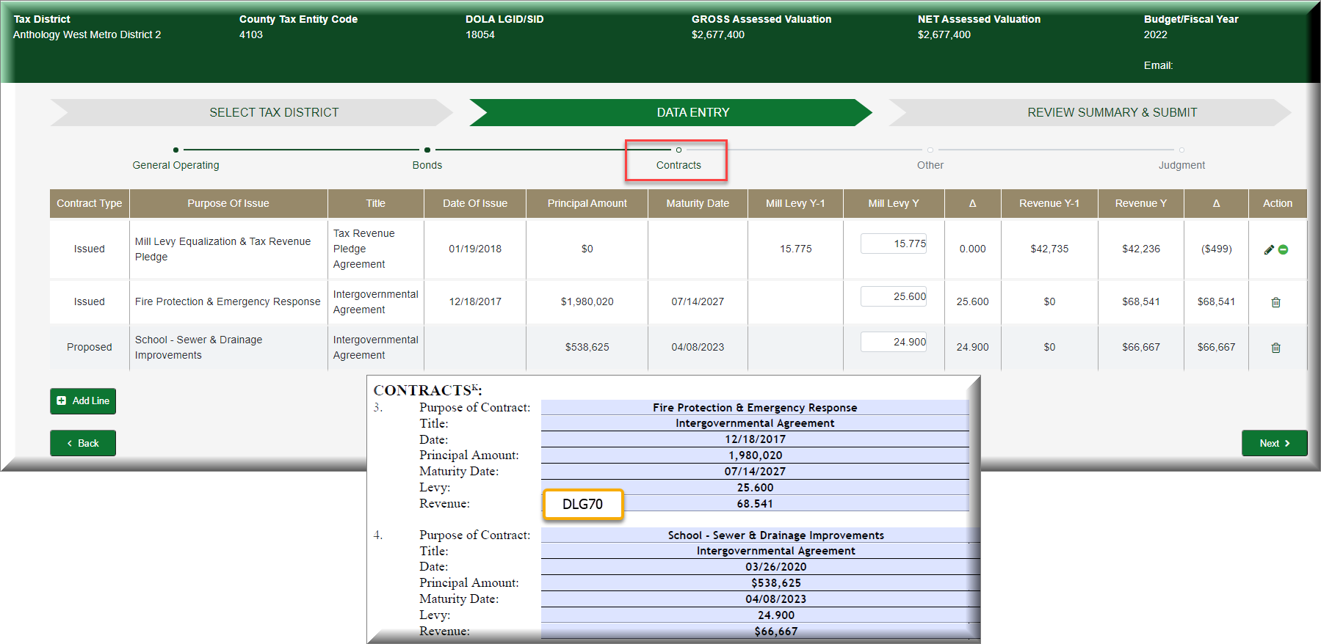

Adding a Contract | Like the Bonds Tab, you can Add a Contract for the Current Year and Delete a Contract that was entered incorrectly. Contracts that have reached their Maturity date can also be inactivated. Contracts can also be reactivated.  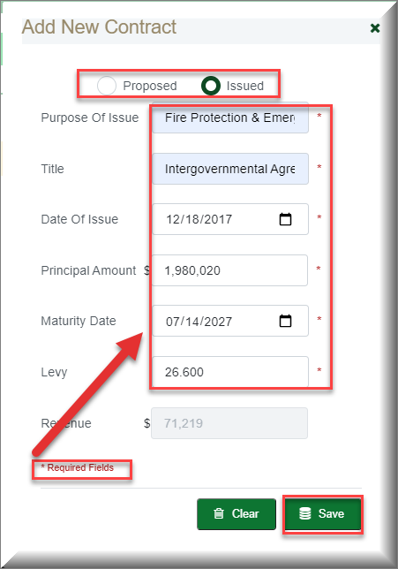  - Follow the same steps for Inactivate and Deletions as you followed for Bonds. “Add Line”

The Other Tab | The Other Tab allows you to view Other mill levies from the previous year and the mills associated with them. You can also add new Other mill levies as we discussed in the Bonds and Contracts Tabs. Other Mill Levy entries can be inactivated and reactivated.
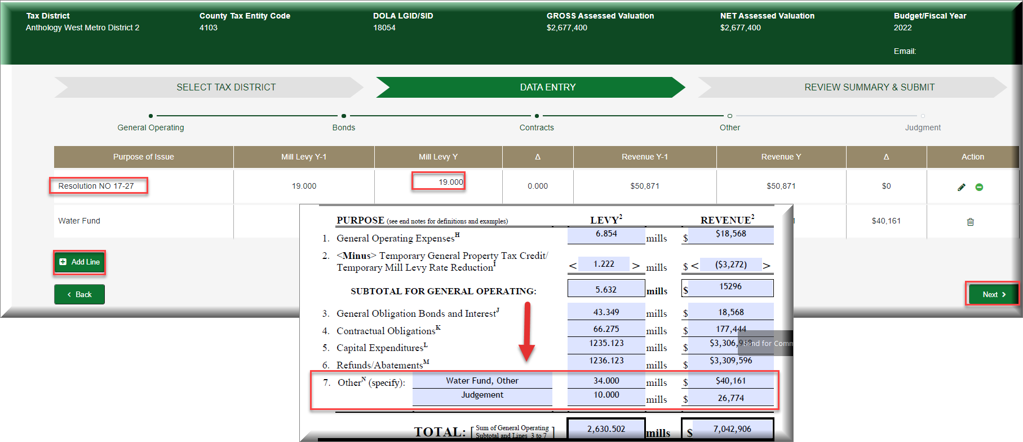

Adding a mill levy to the Other Tab | To add an “Other mill levy” to the Other Tab  - Click on Add Line  - Update the Purpose of Issue  - Add the Levy  - Click on Save  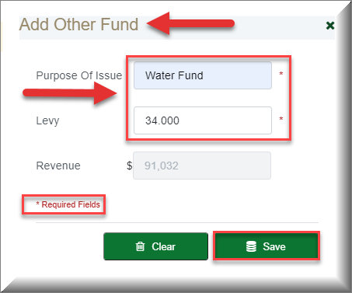

Judgment Tab | The Judgments screen is a read only screen and only the Budget Department can update this screen.  You will See the following information displayed:  - Claimant  - Current Years Mill  - Revenue
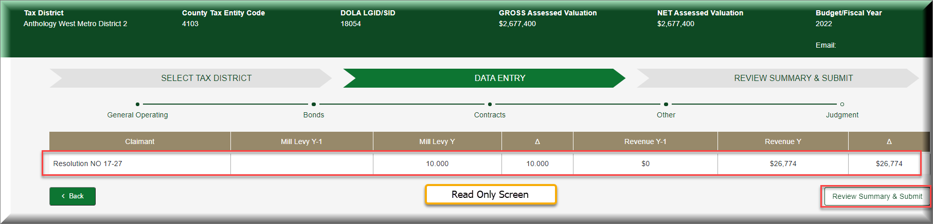

Summary Tab | The Review Summary & Submit Screen allows you to review your Mill Levy data entry before submitting for Certification  - Your updated Mill Levy data is displayed below the “Mill Levy Y” column.  - You can review the Revenue for the Current year.  - You can see the changes from the previous and current years Revenue figures.  - If you find the data is incorrect, select then Click on the “Data Entry” Process Arrow to go back to the appropriate screen and make your edits  - If there was a change to the Mill Levy from the previous year, then you may enter an explanation for the change in the” Explanation of Change” field.  - View Draft: Pending Certification - Allows you to download a draft before submitting for Certification.  - If everything is correct, select the “Submit for Certification” button.

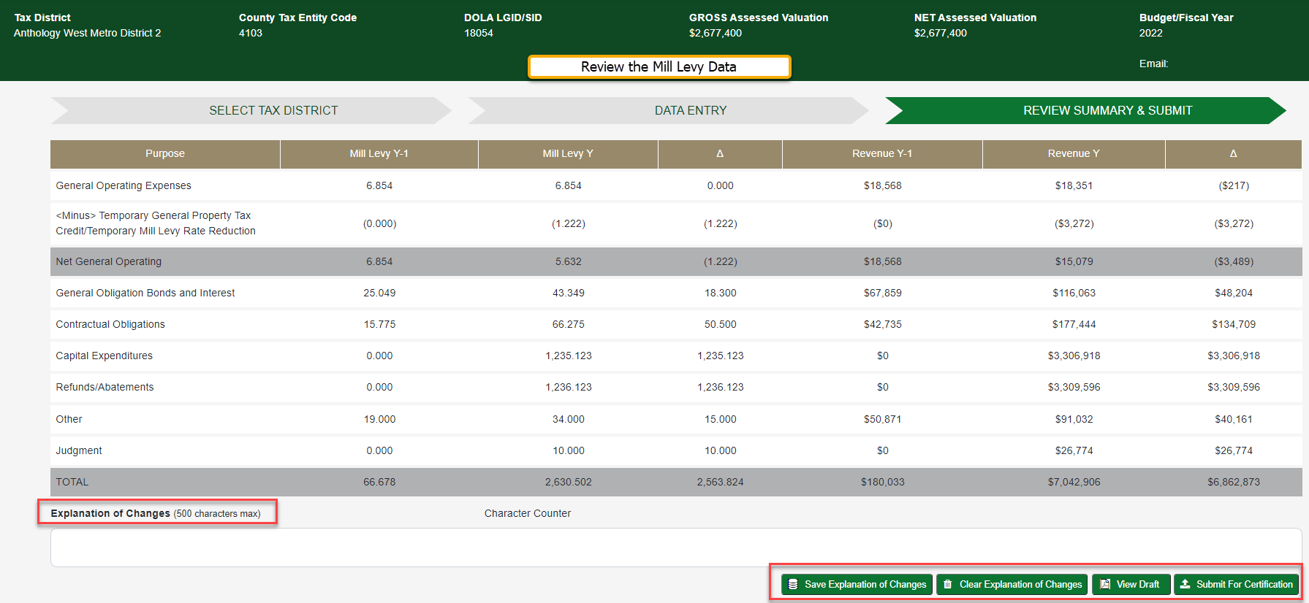

View Draft | The View Draft - Pending Certification allows you to print out a draft summarizing the Purpose, Milly Levy and Revenue  - This is a Draft  - This is great for Firms that file multiple Mill Levies for different Tax Districts  - This allows for others to review the Mills before certification  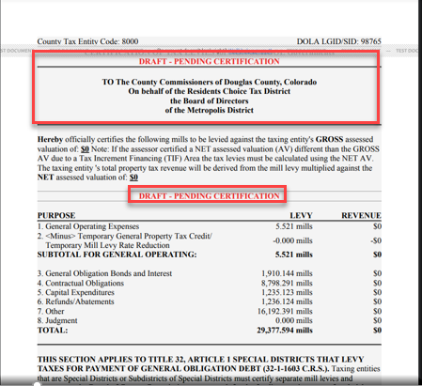

Submit for Certification | After selecting “Submit for Certification” from the Summary Tab, you will complete the following steps:  - Enter any additional email addresses who should receive the certification email.  - Review the disclosure documentation.  Select the “Certify” button to submit this Year’s Mill Levy to the Douglas County Government.  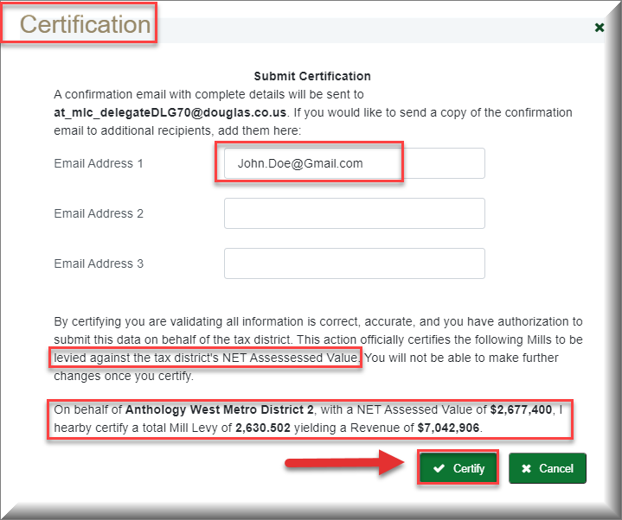

Not Ready to Submit for Certification | When accessing the Submit for Certification screen and you’re not ready to certify:  - Click on “Cancel” to exit the Submit for Certification Screen.  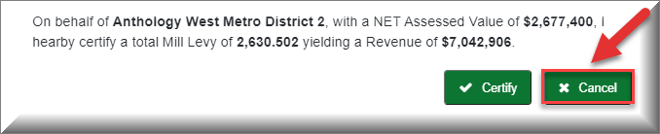

Certification Email | After Successfully submitting your Mill Levy for Certification, you will receive a Confirmation Email.
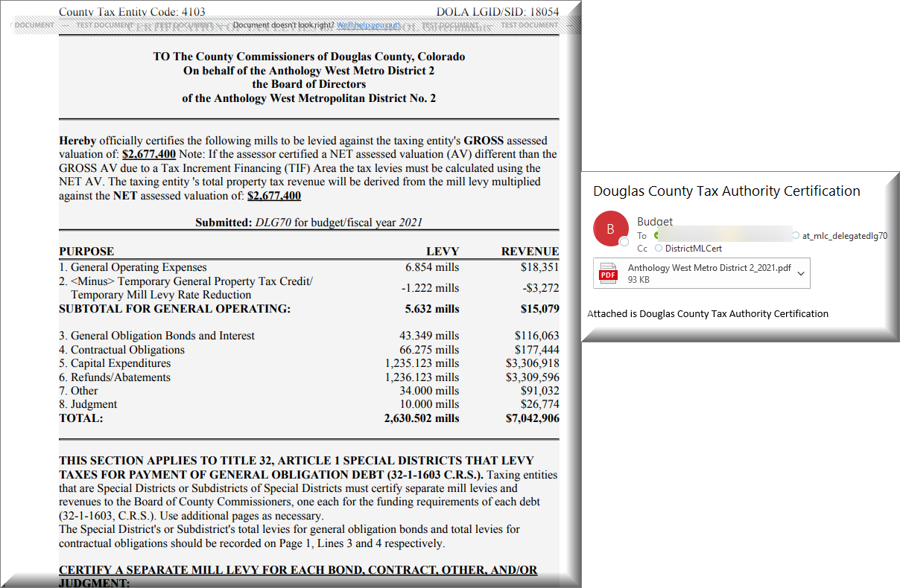

User Guide Discussion Topics:
Bond Tab | Some of the Tax Districts have provided a single Mill Levy for items that may have multiple funds associated.  There are examples of Tax Districts that have enter 2 bonds on their DLG 70 form with Bond (A) listed as 3.500 mills and Bond (B) listed as 0.000 mills.  - The total Mill Levy is 3.500  We recommend you follow the example below when entering the Mills into the Application:
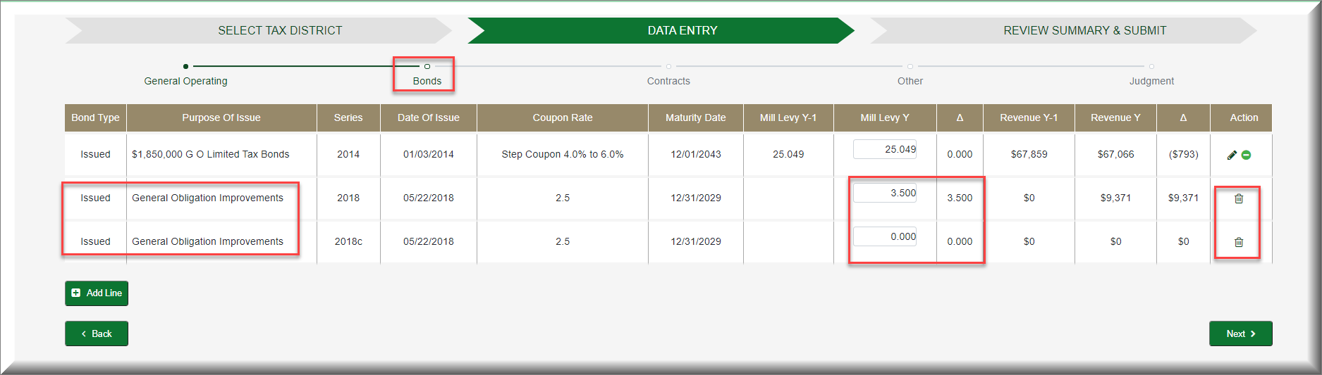

Explanation of Change | After adding the new bonds to the Bond Tab, please access the Summary Tab and add an explanation to the “Explanation of Change” Field  - The Bond Mills for 2018a and 2018b are 2 separate mills that have been calculated and the sum was entered into the 2018a Bond as 7.000 mills.  