
Budget Department
www.douglas.co.us

Mill Levy Certification Application - Reset Password

Process Steps | - Access the Mill Levy Certification Application home page using Chrome browser.  - For training: https://uaapps.douglas.co.us/mill-levy/login  - Click the Forgot Password link.  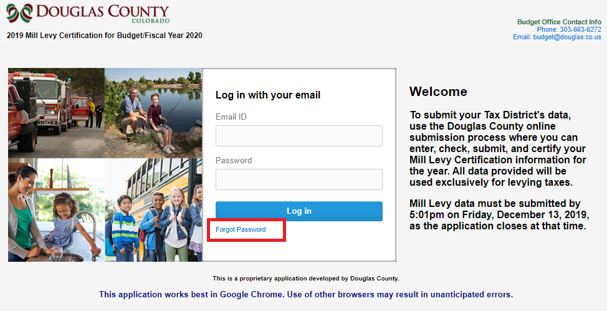  - On the Forgot Password page:  - Enter your email address.  - Click the Send button.  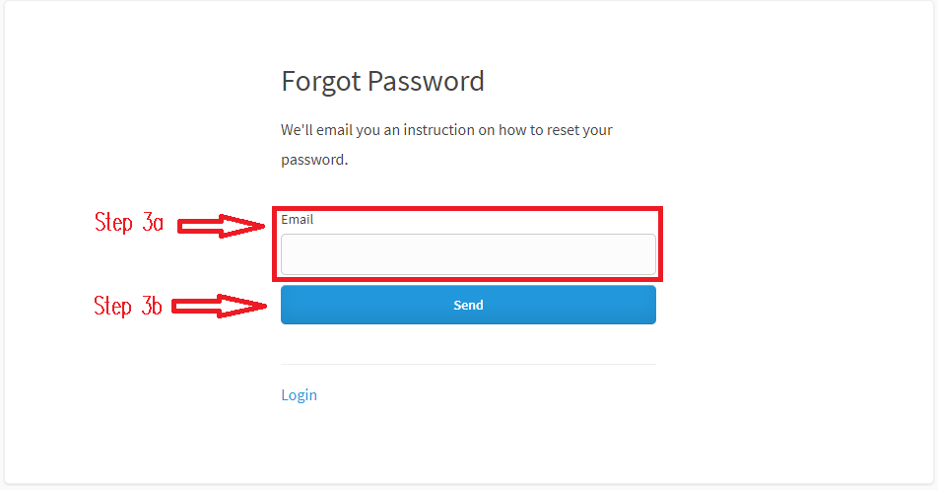  - Check your email for an email with the Subject: “Please reset your password”.  - Be sure to check your junk folder as well.  - If the email is in the junk folder, move the email to your Inbox so that the “From” address is stored as a safe email sender.  - Within the email, read the instructions and click the hyperlink to choose a new password. You may need to copy the URL and paste it into the internet browser.  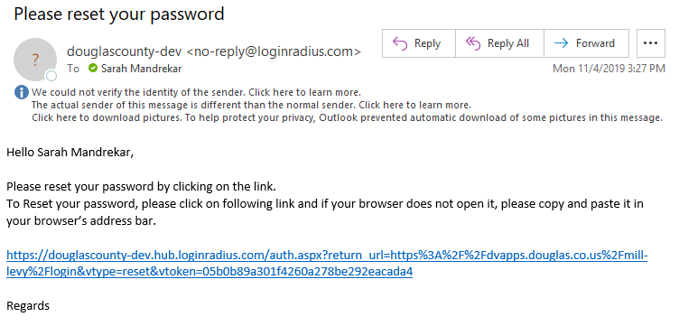  - In the Reset your Password window:  - Enter a new password  - Confirm the password  - Click the Reset password button.  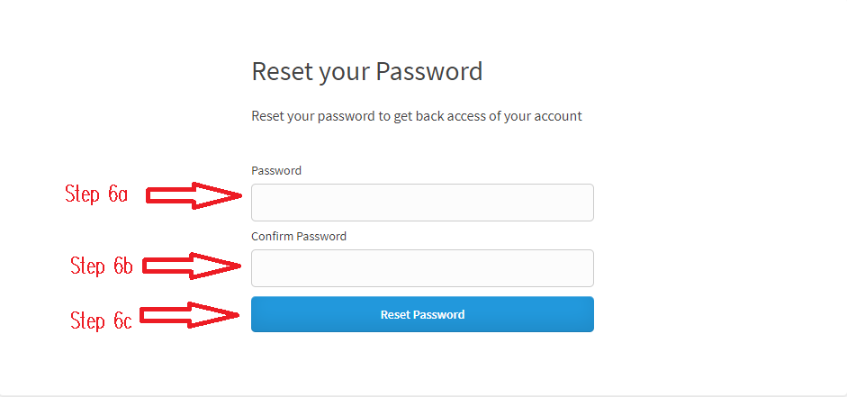  - If your passwords do not match, you will receive a message on the screen. Follow Step 6 to re-enter a password.  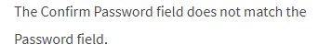  - You will be taken to the login page for the application. Enter your Email id (your email address) and new password to log in.

